|  |  |
| --- | --- |
|  | 4/4/2020  Bound Metal Deposition |
| PHASE-FIELD in MOOSE | |
|  | |
| DGL, VH, KRW  TP project | |

# Contents

Contents 2

List of Figures 3

List of Tables 3

I. Model development in MOOSE 4

A. Adding one more particle in 2D (sint_t1_isomob_3gr.i) 4

B. Coupling to elastic stress (sint_t1_isom_3gr_el_3S.i) 5

C. Increase dimension to 3D (sint_3gr_3.i) 6

1. Grain growth 3D (grain_growth_3D_random.i). 7

2. Changing Conserved.i to 3D 7

3. Changing location of the particles in sint_3gr_3 8

D. 2D model with more than 3 particles 8

E. Adding periodic boundary conditions 9

F. Gravity (sint1_isom_9gr_el_2d_PG_02_m3_0.i) 10

G. UNITS 12

1. Phase field 12

2. A, B, M, L and $κ$ coefficients 13

3. Mechanics 14

4. Modifying code 15

H. Example. Spinodal decomposition (https://mooseframework.inl.gov/old/wiki/MooseTutorials/IronChromiumDecomposition/) 16

1. Units 16

2. S1_testmodel.i (s1_testmodel.i) 16

3. S2_testmodel.i (s2_fasttest.i) 17

I. A phase field model of pressure-assisted sintering (Dzepina et al., 2019) 17

II. Thermomechanical coupling 17

A. Simple examples 17

1. circle_thermal_expansion_stress.i (combined examples) 17

B. Darcy Flow Tutorial 18

1. Equations of motion (https://mooseframework.inl.gov/old/wiki/MooseTutorials/DarcyThermoMechanical/Problem/) 18

2. Steps 18

a) Step 01 (https://mooseframework.inl.gov/old/wiki/MooseTutorials/DarcyThermoMechanical/Step01/) 18

b) Step 2 (https://mooseframework.inl.gov/old/wiki/MooseTutorials/DarcyThermoMechanical/Step02/ ) 19

c) Step 3 (https://mooseframework.inl.gov/old/wiki/MooseTutorials/DarcyThermoMechanical/Step03/ ) 19

d) Step 4 19

e) Step 5. Heat conduction 20

f) Step 6 Darcy and heat conduction coupling 20

g) Step9 21

III. Using SINK boundary conditions 21

A. Basic sink formulation 21

B. Sink tests (https://www.mooseframework.org/modules/porous_flow/tests/sinks/sinks_tests.html#! ) 22

1. Test 1 22

2. Gaussian moving heat source 22

IV. Adding heat source to the phase-field model of sintering 23

References 24

# List of Figures

Figure 1 The output ov Sudipta code for sintering two solid particles. 4

Figure 2 Three sintered particles. 4

Figure 3 Displacement (top) and stress $σ11$ (bottom) for three sintered particles. Notice large changes of the values for both quantities (units?) 6

Figure 4. The outcome of the simulations of three particles sintering (without coupling to the mechanical energy) in 3D. Initial structure on the left final on the right. 7

Figure 5. Results of the simulation of the grain growth model modified to work in 3D 7

Figure 6. The results of simulations of sintering three particles in 3D with modified initial location 8

Figure 7. Random initial location of circles for sintering. We choose circles highlighted red for our simulations. 9

Figure 8. Results of simulations for sintefring of 9 particles coupled to the stress. 9

Figure 9 Periodic BC are imposed in xy directions. In addition, Dirichlet BC for the strain are imposed at the top and bottom y axis. 10

Figure 10. Periodic BC in XY direction. No Dirichlet BC. 10

Figure 11. Results of the simulations for G=0.2 m/s2 and D = 2 kg/m3. 11

Figure 12. (left) The results of the simuations of concentration for G=2 m/s2; D=2 kg/m3; =-3 m/m; and $y_b$ = 0 m/m. (right) Stress $σ11$. 11

*Figure 13 Dimensional and nondimensionalized mobilities used in the parameteric studies in (Biswas et al., 2016)* 13

Figure 14 Tungsten diffusion coefficients (C. Minkwitz, 1997) 14

Figure 15 Surface energy, grain boundary energy and ideal work of grain boundary decohesion for tungsten with different impurities. (Grujicic et al., 1999) 14

Figure 16 Full sintering of a set of spherical particles. 16

Figure 17 Table of material constants and model parameters for diamond-nickel sintering. 17

Figure 18 Mesh and results of simulation of the heat conduction in a circular domain. 17

Figure 19 Solution of Step1.i 19

Figure 20 Solution of Step2.i 19

Figure 21 Results of simulatins at Step9.i 21

# List of Tables

Table 1 Script for thermomechanical coupling in a circular domain. 18

Table 2 Additions at step 4 19

Table 3 Heat conduction: step5c_outflow.i (check the steady version Step5a_steady.i) 20

Table 4 Step6_coupled.i 20

Table 5 Step9.i 21

Table 6. Script for Test1 of sink 22

Table 7 Moving Gaussiaan source for pure heat conduction in generic material 22

# Model development in MOOSE

We use Idaho National Lab’s (INL’s) Multiphysics Object-Oriented Simulation Environment

(MOOSE) for implementing the current phase field model.

We begin model development by cloning MOOSE script [sintering_test1_isomob.i](https://github.com/SudiptaBiswas/Crow/blob/devel/test/tests/sintering_test1_isomob.i) written by Sudipta Biswas (<https://github.com/SudiptaBiswas/Crow/tree/devel>).

The original code models sintering of two particles that is not coupled to neither solid mechanics nor the thermal conduction. However, it was demonstrated in earlier publications ([1], [2], [4], [7], [8], [9], [10]) that this code can be extended to couple phase field equations to mechanical stress and thermal conduction.

Figure 1 The output ov Sudipta code for sintering two solid particles.

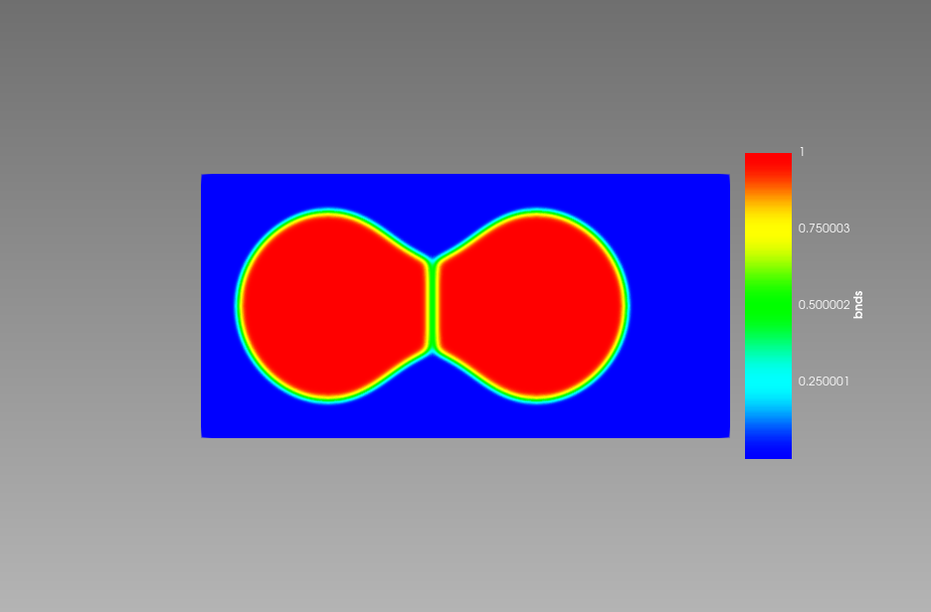

## Adding one more particle in 2D ([sint_t1_isomob_3gr.i](https://github.com/luchinsky/Crow/blob/develD/test/tests/3gr/sint_t1_isomob_3gr.i))

To add one more particle we have changed global parameter op_num to 3

  op_num = 3.0

and added new variable gr2 at every location where we see variables gr0 and gr1. For example, in the module IC’s we have added.

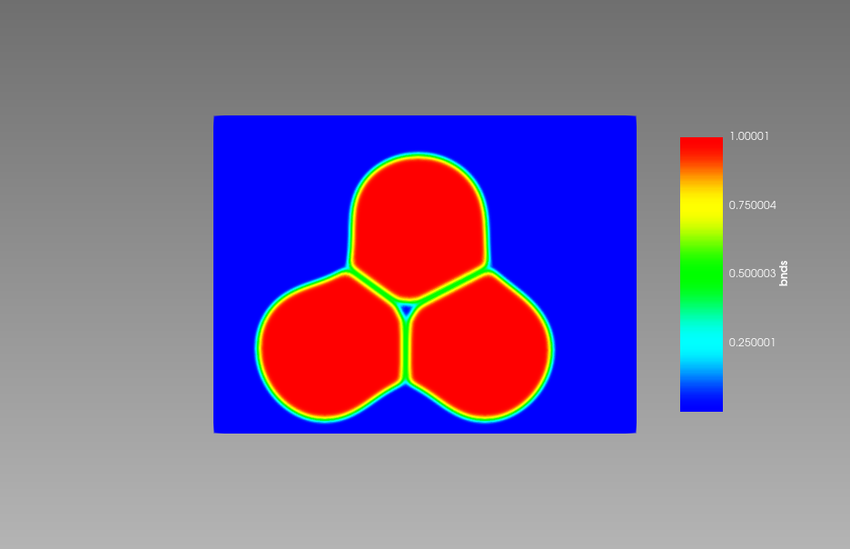

We have also changed coordinates of all particles to ensure initial contact.

Figure 2 Three sintered particles.

  [./ic_gr2]

    int_width = 2.0

    x1 = 25.2

    y1 = 8.0

    radius = 7.0

    outvalue = 0.0

    variable = gr2

    invalue = 1.0

    type = SmoothCircleIC

  [../]

## Coupling to elastic stress ([sint_t1_isom_3gr_el_3S.i](https://github.com/luchinsky/Crow/blob/develD/test/tests/3gr_Fc_Fe/sint_t1_isom_3gr_el_3S.i))

A few ways are available to couple the model to mechanical stress. Here we use one of the simplest methods based on extension of the following example: [Conserved3d.i](https://github.com/luchinsky/Crow/blob/develD/examples/combined/phase-field-mechanics/Conserved/Conserved3d.i) .

The main changes include:

* Add displacement to global parameters: displacements = 'disp_x disp_y'
* Add displacements to the definition of variables

  [./disp_x]

    order = FIRST

    family = LAGRANGE

  [../]

  [./disp_y]

    order = FIRST

    family = LAGRANGE

  [../]

* Add auxiliary variables (note that the IC’s did not change)

  [./sigma11_aux]

    order = CONSTANT

    family = MONOMIAL

  [../]

  [./sigma22_aux]

    order = CONSTANT

    family = MONOMIAL

  [../]

* Add TensorMechanics to the Kernels

  [./TensorMechanics]

    displacements = 'disp_x disp_y'

  [../]

* Add stress calculations to auxiliary kernals

  [./matl_sigma11]

    type = RankTwoAux

    rank_two_tensor = stress

    index_i = 0

    index_j = 0

    variable = sigma11_aux

  [../]

  [./matl_sigma22]

    type = RankTwoAux

    rank_two_tensor = stress

    index_i = 1

    index_j = 1

    variable = sigma22_aux

  [../]

* Add boundary conditions

  [./bottom_y]

    type = DirichletBC

    variable = disp_y

    boundary = 'bottom'

    value = 0

  [../]

  [./top_y]

    type = DirichletBC

    variable = disp_y

    boundary = 'top'

    value = -5

  [../]

  [./left_x]

    type = DirichletBC

    variable = disp_x

    boundary = 'left'

    value = 0

  [../]

* Add materials to calculate Elastic Free Energy (note that at this stage it was not possible to exclude any of this materials)

  [./elasticity_tensor]

    type = ComputeElasticityTensor

    block = 0

    # lambda, mu values

    C_ijkl = '7 7'

    # Stiffness tensor is created from lambda=7, mu=7 using symmetric_isotropic fill method

    fill_method = symmetric_isotropic    # See RankFourTensor.h for details on fill methods

  [../]

  [./stress]

    type = ComputeLinearElasticStress

    block = 0

  [../]

    [./var_dependence]

    type = DerivativeParsedMaterial

    block = 0

    function = 0.2*c

    args = c

    f_name = var_dep

    enable_jit = true

    derivative_order = 2

  [../]

  [./eigenstrain]

    type = ComputeVariableEigenstrain

    block = 0

    eigen_base = '1 1 1 0 0 0'

    prefactor = var_dep

    args = 'c'

    eigenstrain_name = eigenstrain

  [../]

  [./strain]

    type = ComputeSmallStrain

    block = 0

    displacements = 'disp_x disp_y'

    eigenstrain_names = eigenstrain

  [../]

  [./elastic_free_energy]

    type = ElasticEnergyMaterial

    f_name = Fe

    block = 0

    args = 'c'

    derivative_order = 2

  [../]

* Use SinteringFreeEnergy as partial chemical free energy

  [./chemical_free_energy]

    type = SinteringFreeEnergy

    block = 0

    c = c

    v = 'gr0 gr1 gr2'

    f_name = Fc

    derivative_order = 2

  [../]

* Add sum of two free energies: Fc and Fe (chemical and elastic)

  [./free_energy]

    type = DerivativeSumMaterial

    block = 0

    f_name = F

    sum_materials = 'Fc Fe'

    args = 'c'

    derivative_order = 2

  [../]

* Add elastic and chemical free energy to the output

  [./el_free_en]

    type = ElementIntegralMaterialProperty

    mat_prop = Fe

  [../]

  [./ch_free_en]

    type = ElementIntegralMaterialProperty

    mat_prop = Fc

  [../]

The output for displacement and stress of three sintered particles is shown in Figure 3. The important highlight at this stage is that the observed changes are significant and these changes follow the sintering dynamics.

## Increase dimension to 3D ([sint_3gr_3.i](https://github.com/luchinsky/Crow/blob/develD/test/tests/3gr_2/sint_3gr_3.i))

This extension does not work properly yet. The following changes have been introduced

* Mesh

[Mesh]

  type = GeneratedMesh

  dim = 3

  nx = 16

  ny = 16

  nz = 8

  xmin = 0.0

  xmax = 40.0

  ymin = 0.0

  ymax = 30.0

  zmin = 0

  zmax = 30.0

  elem_type = HEX8

[]

However, the outcome of the simulations shown in Figure 4 reveals the fact that the particles grow in two dimensions.

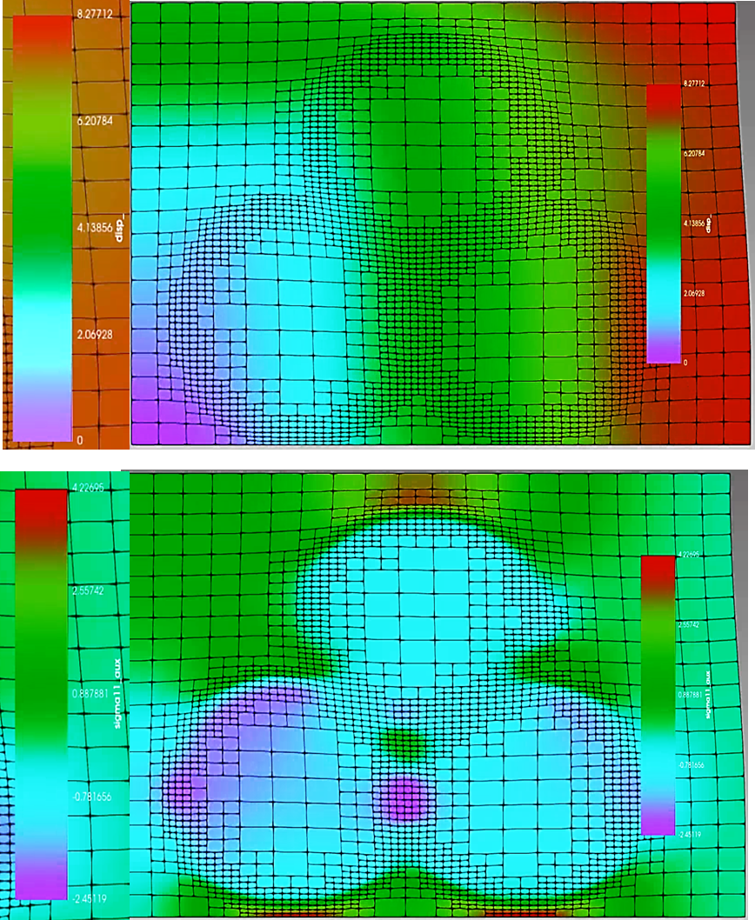

Figure 3 Displacement (top) and stress $σ_{11}$ (bottom) for three sintered particles. Notice large changes of the values for both quantities (units?)

To analyze the issue the following tests were performed. We check a few 3D tests from MOOSE

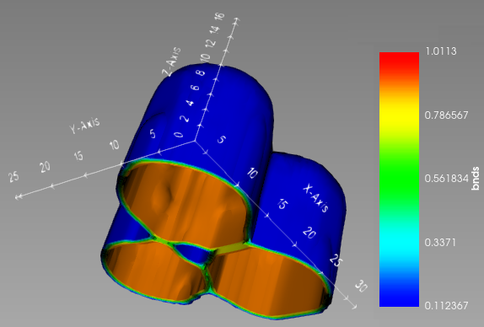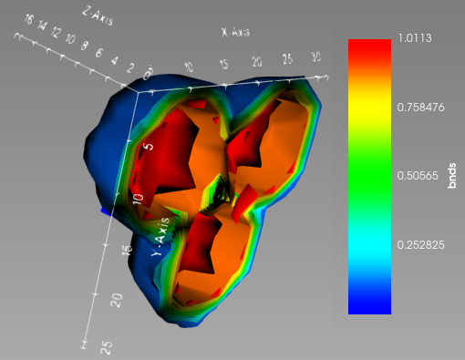

Figure 4. The outcome of the simulations of three particles sintering (without coupling to the mechanical energy) in 3D. Initial structure on the left final on the right.

### Grain growth 3D ([grain_growth_3D_random.i](https://github.com/luchinsky/Crow/blob/develD/examples/phase-field/PFtests/grain_growth/grain_growth_3D_random.i)).

# This simulation predicts GB migration of a 2D copper polycrystal with 100 grains represented with 18 order parameters

# Mesh adaptivity and time step adaptivity are used

# An AuxVariable is used to calculate the grain boundary locations

# Postprocessors are used to record time step and the number of grains

We modify this example to work in 3D.

[Mesh]

  # Mesh block.  Meshes can be read in or automatically generated

  type = GeneratedMesh

  dim = 3 # Problem dimension

  nx = 10 # Number of elements in the x-direction

  ny = 10 # Number of elements in the y-direction

  nz = 10

  xmin = 0    # minimum x-coordinate of the mesh

  xmax = 1000 # maximum x-coordinate of the mesh

  ymin = 0    # minimum y-coordinate of the mesh

  ymax = 1000 # maximum y-coordinate of the mesh

  zmin = 0

  zmax = 1000

  uniform_refine = 1 # Initial uniform refinement of the mesh

  parallel_type = distributed

[]

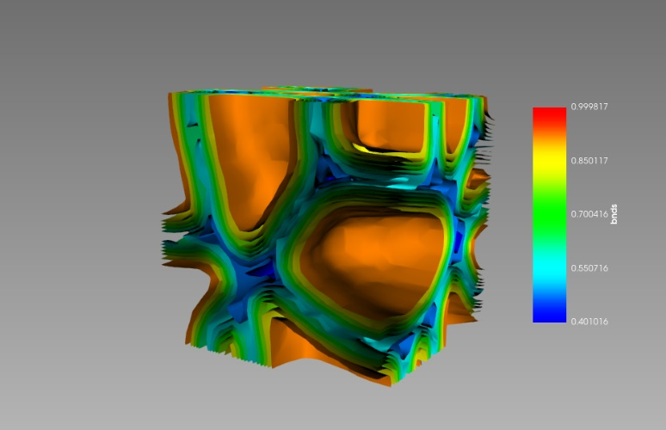

Figure 5. Results of the simulation of the grain growth model modified to work in 3D

The results of the simulations are shown in Figure 5.

### Changing [Conserved.i](https://github.com/luchinsky/Crow/blob/develD/examples/combined/phase-field-mechanics/Conserved/Conserved.i) to 3D

Similarly, the MOOSE example [Conserved_3d.i](https://github.com/luchinsky/Crow/blob/develD/examples/phase-field/phase_field-mechanics/Conserved/Conserved_3d.i) was modified to work in 3D.

# Example 1.

# Illustrating the coupling between chemical and mechanical (elastic) driving forces.

# An oversized precipitate deforms under a uniaxial compressive stress

# Check the file below for comments and suggestions for parameter modifications.

By changing mesh options

[Mesh]

  type = GeneratedMesh

  dim = 3

  nx = 16

  ny = 16

  nz = 8

  xmin = 0

  xmax = 50

  ymin = 0

  ymax = 50

  zmin = 0

  zmax = 50

  elem_type = HEX8

[]

### Changing location of the particles in sint_3gr_3

We have changed the location of the particles in the original code discussed in Section C above

The new code is [sint_3gr_3d_1.i](https://github.com/luchinsky/Crow/blob/develD/test/tests/3gr_2/sint_3gr_3d_1.i) . In the new code only the initial conditions have been changed

|  |  |
| --- | --- |
| [ICs]    [./ic_gr2]      int_width = 2.0      x1 = 25.2      y1 = 8.0      z1 = 12.0      radius = 7.0      outvalue = 0.0      variable = gr2      invalue = 1.0      type = SmoothCircleIC    [../]    [./ic_gr1]      int_width = 2.0      x1 = 19.367      y1 = 19.488      z1 = 18.0      radius = 6.0      outvalue = 0.0      variable = gr1      invalue = 1.0      type = SmoothCircleIC    [../] | [./ic_gr0]      int_width = 2.0      x1 = 11.0      y1 = 8.0      z1 = 14.0      radius = 7.4      outvalue = 0.0      variable = gr0      invalue = 1.0      type = SmoothCircleIC    [../]    [./multip]      x_positions = '11.0 19.367  25.2'      int_width = 2.0      z_positions = '14 18 12'      y_positions = '8.0 19.488 8.0 '      radii = '7.4 6.0 7.0'      3D_spheres = false      outvalue = 0.001      variable = c      invalue = 0.999      type = SpecifiedSmoothCircleIC      block = 0    [../] |

We shifted the location of the particles to the center of the cell. The result of simulations is shown in the Figure 6.

We note that it takes quite some time to simulate three particles sintering in this code. So, for now we return to the 2D simulations.

## 2D model with more than 3 particles

We use as a prototype the model [sint_t1_isom_3gr_el_3S.i](https://github.com/luchinsky/Crow/blob/develD/test/tests/3gr_Fc_Fe/sint_t1_isom_3gr_el_3S.i) developed in Section B. The changes he changes in the script are the following, cf changes in Section B.

Figure 6. The results of simulations of sintering three particles in 3D with modified initial location

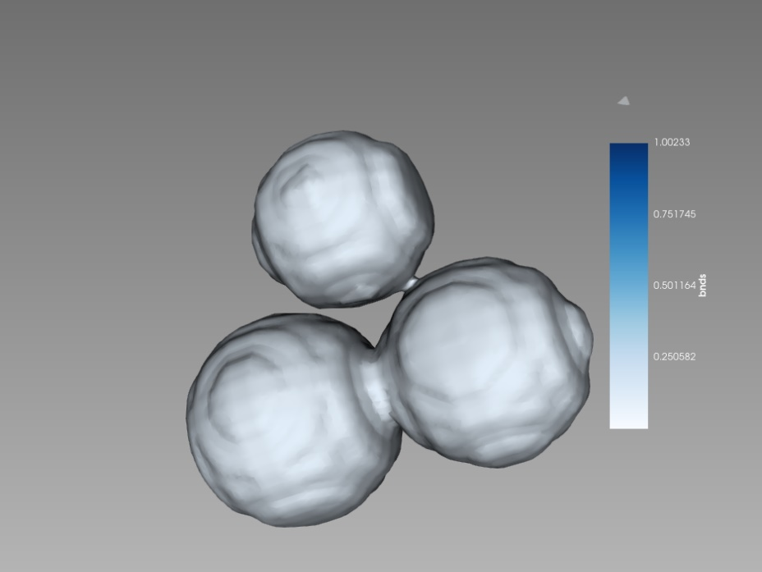

|  |  |  |
| --- | --- | --- |
| type = GeneratedMesh    dim = 2    nx = 60    ny = 60    #   nz = 0    xmin = 0.0    xmax = 40.0    ymin = 0.0    ymax = 40.0    # zmax = 0    elem_type = QUAD4  []  **[GlobalParams]**    displacements = 'disp_x disp_y'    var_name_base = gr    op_num = 9.0    int_width = 1.0    #en_ratio = 1  []  **[Variables]**  **[./c]**      #scaling = 10    [../]  **[./w]**    [../]  **[./PolycrystalVariables]**    [../]  **[./disp_x]**      order = FIRST      family = LAGRANGE    [../]  **[./disp_y]**      order = FIRST      family = LAGRANGE    [../]  **[ICs]**  **[./ic_gr8]**      int_width = 2.0      x1 = 18.9158      y1 = 18.2981      radius = 3.895      outvalue = 0.0      variable = gr8      invalue = 1.0      type = SmoothCircleIC    [../]  **[./ic_gr7]**      int_width = 2.0 | x1 = 10.6328      y1 = 29.4843      radius = 3.75      outvalue = 0.0      variable = gr7      invalue = 1.0      type = SmoothCircleIC    [../]  **[./ic_gr6]**      int_width = 2.0      x1 = 21.7174      y1 = 15.3236      radius = 3.75      outvalue = 0.0      variable = gr6      invalue = 1.0      type = SmoothCircleIC    [../]  **[./ic_gr5]**      int_width = 2.0      x1 = 20.0109      y1 = 30.5594      radius = 4.32      outvalue = 0.0      variable = gr5      invalue = 1.0      type = SmoothCircleIC    [../]  **[./ic_gr4]**      int_width = 2.0      x1 = 27.8199      y1 = 28.1836      radius = 3.375      outvalue = 0.0      variable = gr4      invalue = 1.0      type = SmoothCircleIC    [../]  **[./ic_gr3]**      int_width = 2.0      x1 = 22.0109      y1 = 22.7441      radius = 3.375      outvalue = 0.0      variable = gr3      invalue = 1.0      type = SmoothCircleIC    [../] | **[./ic_g2]**      int_width = 2.0      x1 = 13.5818      y1 = 17.6532      radius = 3.375      outvalue = 0.0      variable = gr2      invalue = 1.0      type = SmoothCircleIC    [../]  **[./ic_gr1]**      int_width = 2.0      x1 = 8.592      y1 = 22.4133      radius = 3.25      outvalue = 0.0      variable = gr1      invalue = 1.0      type = SmoothCircleIC    [../]  **[./ic_gr0]**      int_width = 2.0      x1 = 15.6702      y1 = 24.1294      radius = 3.25      outvalue = 0.0      variable = gr0      invalue = 1.0      type = SmoothCircleIC    [../]  **[./multip]**      x_positions = '28.9158 10.6328  21.7174 20.0109 27.8199 22.9458 13.5818 8.592 15.6702'      y_positions = '18.2981 29.4843  15.3236 30.5594 28.1836 22.7441 17.6532 22.4133 24.1294'      z_positions = '0 0 0 0 0 0 0 0 0'      radii = '3.875  3.75  3.75  4.325 3.5 3.375 3.375 3.25  3.25'      int_width = 2.0      3D_spheres = false      outvalue = 0.001      variable = c      invalue = 0.999      type = SpecifiedSmoothCircleIC      block = 0    [../]  [] |

To find initial position of the particles we use matlab code bubblebath.m to generate initial random location of particles.

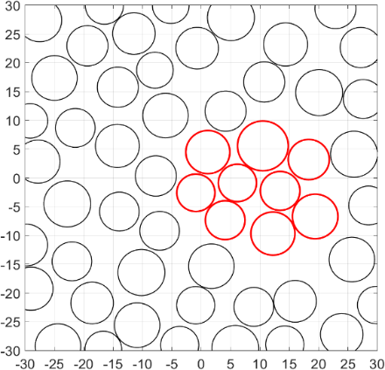

Figure 7. Random initial location of circles for sintering. We choose circles highlighted red for our simulations.

The outcome of simulations is shown in the Figure 8.

Figure 8. Results of simulations for sintefring of 9 particles coupled to the stress.

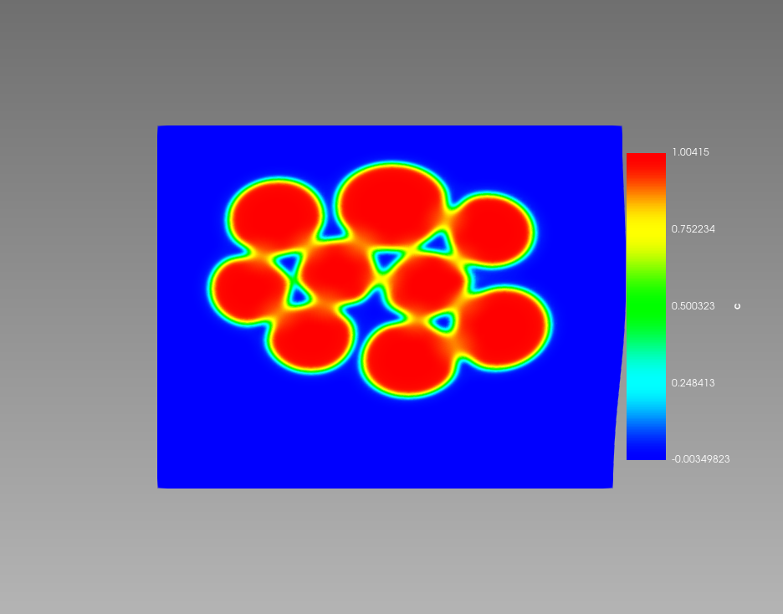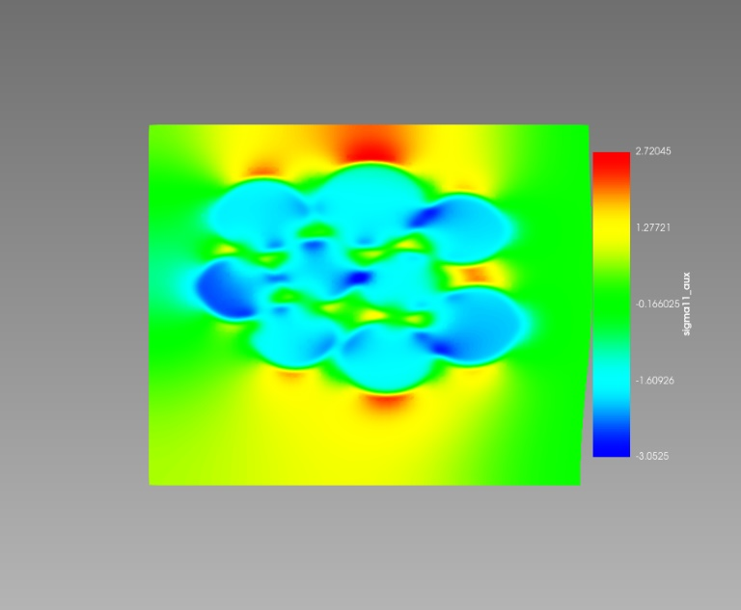

## Adding periodic boundary conditions

Periodic BC ([sint1_isom_9gr_el_2d_P.i](https://github.com/luchinsky/Crow/blob/develD/test/tests/9gr_2d/sint1_isom_9gr_el_2d_P.i)) and ([sint1_isom_9gr_el_2d_P1.i](https://github.com/luchinsky/Crow/blob/develD/test/tests/9gr_2d/sint1_isom_9gr_el_2d_P1.i))

MOOSE provides built-in support for specifying periodic boundary conditions. The [periodic_bc.i](https://github.com/idaholab/moose/blob/next/examples/ex04_bcs/periodic_bc.i) input file demonstrates this functionality while also taking advantage of MOOSE's ability for parsing user-specified analytical functions from input files. Parsed functions can be used to do many things in input files and are discussed in more detail in [Example 13](https://mooseframework.inl.gov/examples/ex13_functions.html).

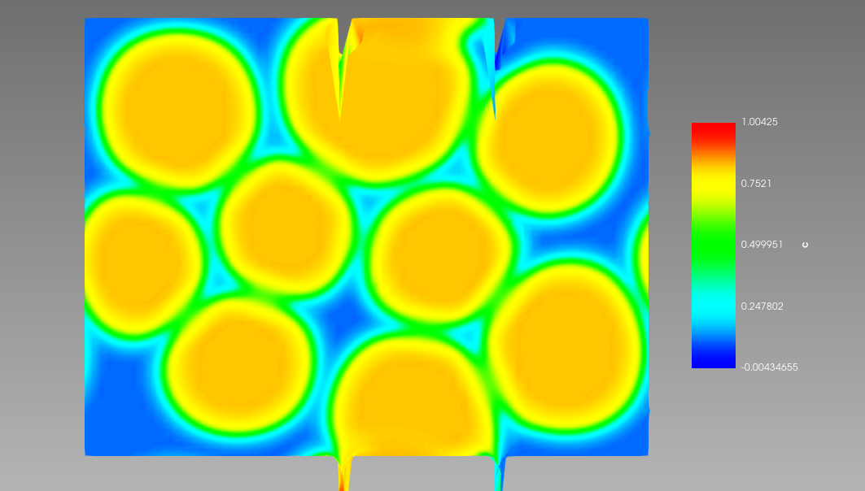

Figure 9 Periodic BC are imposed in xy directions. In addition, Dirichlet BC for the strain are imposed at the top and bottom y axis.

In the first example we impose periodic BC in XY directions. In addition, Dirichlet BC for the strain are imposed at the top and bottom y axis. The simulation results are shown in Figure 9.

The artifacts observed at the top and bottom are, I believe, due to incompatibility of the periodic and Dirichlet BC. The corrected results (no Dirichlet BC) are shown in Figure 10.

[BCs]

# Boundary Condition block

  [./Periodic]

    [./top_bottom]

      auto_direction = 'x y' # Makes problem periodic in the x and y directions

    [../]

  [../]

## Gravity ([sint1_isom_9gr_el_2d_PG_02_m3_0.i](https://github.com/luchinsky/Crow/blob/develD/test/tests/9gr_2d/G_02_yt_m3_yb_0/sint1_isom_9gr_el_2d_PG_02_m3_0.i))

[sint1_isom_9gr_el_2d_PG_2_yt_m3_yb_0.i](https://github.com/luchinsky/Crow/blob/develD/test/tests/9gr_2d/G_2_ytm3_yb_0/sint1_isom_9gr_el_2d_PG_2_yt_m3_yb_0.i)

To add gravity we need to

* remove periodic BC and in Y direction
* add gravity value in that direction
* restore Dirichlet BC in this direction (otherwise there is no convergence so far)

Figure 10. Periodic BC in XY direction. No Dirichlet BC.

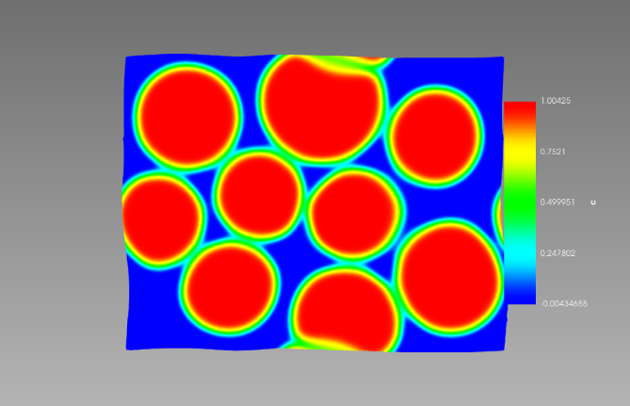

[BCs]

# Boundary Condition block

  [./Periodic]

    [./top_bottom]

      auto_direction = 'x y' # Makes problem periodic in the x and y directions

    [../]

  [../]

   [./bottom_y]

     type = *DirichletBC*

     variable = disp_y

     boundary = 'bottom'

     value = 0

   [../]

   [./top_y]

     type = *DirichletBC*

     variable = disp_y

     boundary = 'top'

     # prescribed displacement

     # -5 will result in a compressive stress

     #  5 will result in a tensile stress

     value = -3

[]

[Kernels]

  [./TensorMechanics]

    displacements = 'disp_x disp_y'

  [../]

  [./gravity_y]

    type = *Gravity*

    variable = disp_y

    # value = -0.2 # 1.81

    value = -2.0 # 1.81

  [../]

[]

There is one more important consideration we have to specify density as a new material property

[Materials]

  [./density]

    type = GenericConstantMaterial

    prop_names = density

    prop_values = 2.0387

  [../]

[]

Figure 11. Results of the simulations for G=0.2 m/s2 and D = 2 kg/m3.

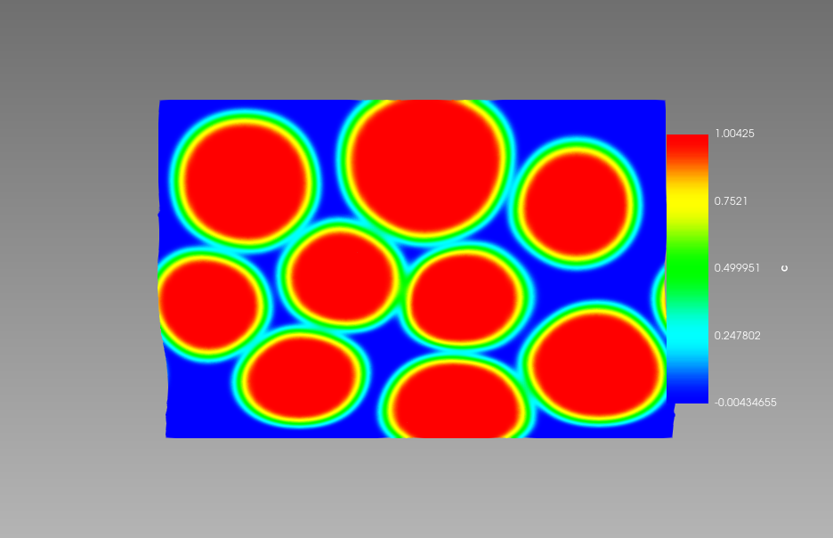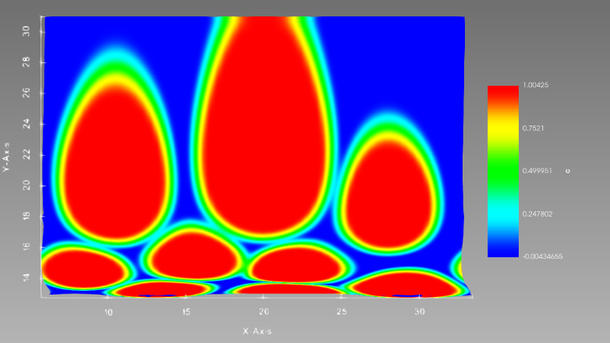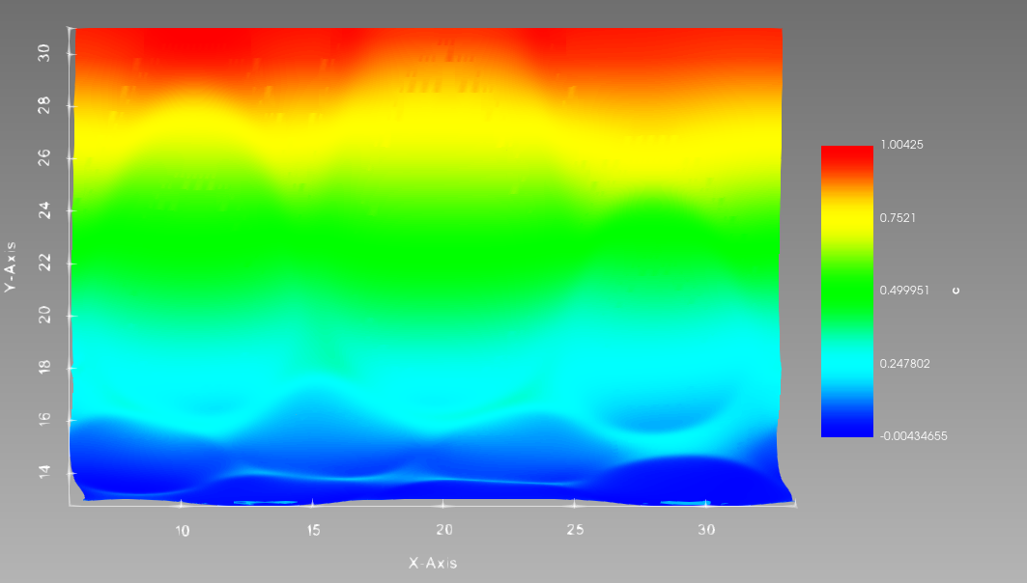

Figure 12. (left) The results of the simuations of concentration for G=2 m/s2; D=2 kg/m3; =-3 m/m; and $y_b$ = 0 m/m. (right) Stress $σ_{11}$.

The importance of the parameter (variable) values is apparent in this example. In the first example G=2 m/s2 and density is D=2 kg/m3. The results of simulations are shown in Figure 11. It is clear, that the density is substantially underestimated. For metals it is expected to be of the order 5 – 10 kg/m3. At the same time the dimensions presented in the figure correspond to mm or even mkm.

The results of the simulations for one more set of parameter values are shown in

For reduced gravity the deformation of the particles is (as expected) substantially smaller than in previous case.

However, the proper choice of the parameter values must be done self-consistently to reflect the dimensions and units of the problem.

## UNITS

Handling Units in MOOSE

### [Phase field](https://mooseframework.inl.gov/old/wiki/PhysicsModules/PhaseField/PhaseFieldUnits/)

There is no inherit unit system in MOOSE. Thus, the units of the phase field equations are set by the user when they define a model. Specifically, the units are set by the local free energy density and the κ and mobility parameters (L and M). The units in all these terms must be consistent. Additional energy sources, such as the elastic energy, also must have consistent units. In the phase field module, all of these values are created using Material objects. Thus, the units of your system are not set by the kernels but rather by the materials.

One useful practice is to create your material objects to take SI units as input parameters. Then use length_scale, time_scale, and energy_scale input parameters to convert the actual units of the problem. As an example of this, see the PFParamsPolyFreeEnergy material, where the input file block looks like

[./Copper]

  type = PFParamsPolyFreeEnergy

  block = 0

  c = c

  T = 1000 # K

  int_width = 30.0

  length_scale = 1.0e-9

  time_scale = 1.0e-9

  D0 = 3.1e-5 # m^2/s, from Brown1980

  Em = 0.71 # in eV, from Balluffi1978 Table 2

  Ef = 1.28 # in eV, from Balluffi1978 Table 2

  surface_energy = 0.7 # J/m^2

[../]

The Cahn-Hilliard equation after the variational derivative takes the form









The Allen-Cahn equation after the variational derivative takes the form 



where $κ_{i}$ and $κ_{j}$ are gradient energy coefficients with the units $e/l$, $E_{d}$ describes any additional sources of energy in the system, such as deformation or electrostatic energy, with units of $e/l^{3},$ the units of $L$ are $l^{3}/(et),$ and the units of $M_{i}$ are $(l^{2}mol)/(et)$. Note that some models include the $V_{m}$ in the mobility term, such that it has units of $l^{5}/(te).$



### A, B, M, L and $κ$ coefficients

With units of $e/l^{3},$ the units of $L$ are $l^{3}/(et),$ and the units of $M_{i}$ are $(l^{2}mol)/(et)$, $κ_{i}$ and $κ_{j}$ are gradient energy coefficients with the units $e/l$.



Mobility coefficients ($M_{i}$) are estimated from corresponding diffusion coefficients as

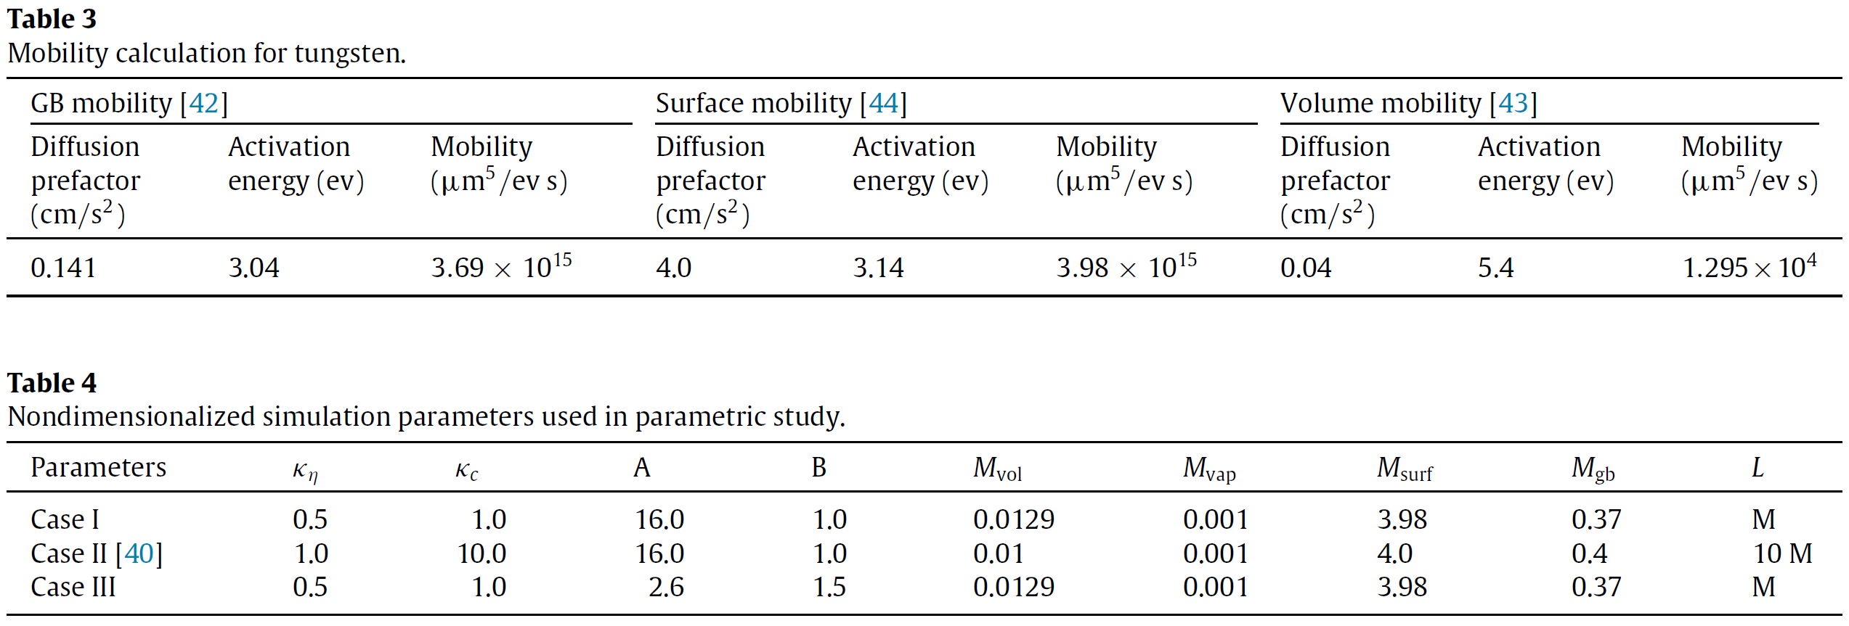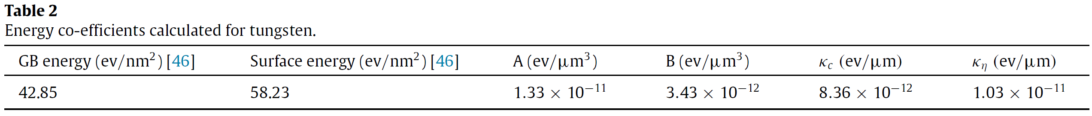

*Figure 13 Dimensional and nondimensionalized mobilities used in the parameteric studies in (Biswas et al., 2016)*

$$M_{i}=\frac{D_{i}V_{m}}{k_{B}T};$$

$$D_{gb}=D_{gb0}e^{-\frac{Q_{gb}}{k_{B}T}}; D_{vol}=D_{vol0}e^{-\frac{Q_{vol}}{k_{B}T}}; D_{s}=D_{s0}e^{-\frac{Q_{s}}{k_{B}T}}.$$

$$κ_{c}=k_{1}\left(2γ_{s}-γ_{gb}\right)⋅δ; κ_{η}=k_{2}γ_{gb}⋅δ; A=\frac{k_{3}\left(12γ_{s}-7γ_{gb}\right)}{δ}; B=\frac{k_{4}γ_{gb}}{δ},$$

$γ_{s}$ and $γ_{gb}$ are the surface and the grain boundary energy, $δ$ is the interface width or the grain boundary thickness. $k_{1}, k_{2}, k_{3}, k_{4}$ are normalization constants.

UNITS. Molar volume of tungsten is $V_{m}= 9.55×{10}^{-6}m^{3}$

|  |  |  |  |  |  |
| --- | --- | --- | --- | --- | --- |
| 1 kcal/mol = | 0.04336 eV |  | 1 kT unit = | 0.5922 kcal/mol |  |
|  | 349.75 cm-1 |  | (for T = 298 K) | 0.02568 eV |  |
|  | 1.689 kT |  |  | 207.1 cm-1 |  |
|  | 4.184 kJ/mol |  |  | 2.476 kJ/mol |  |
|  |  |  |  |  |  |
|  |  |  |  |  |  |
| 1 eV = | 23.06 kcal/mol |  | 1 Hartree = | 1 atomic unit |  |
|  | 8065.6 cm-1 |  |  | 627.51 kcal/mol |  |
|  | 38.94 kT |  |  | 27.2114 eV |  |
|  | 96.49 kJ/mol |  |  | 1059.70 kT |  |
|  |  |  |  |  |  |

Consider one example: $M_{gb}=3.69×{10}^{15}\frac{{μm}^{5}}{eV⋅s}$, $D_{gb0}=0.141\frac{cm^{2}}{s}$, $Q_{gb}=3.04 eV$, $A=1.33× {10}^{-11}\frac{eV}{μm^{3}}$.

Even simper example: $κ_{c}=8.36×{10}^{-12}\frac{eV}{μm}$ while dimensionless value is ~1.

Figure 14 Tungsten diffusion coefficients (C. Minkwitz, 1997)

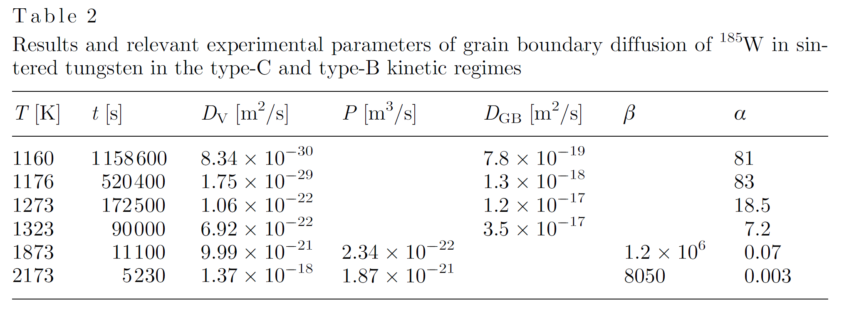

In the code these coefficients are defined in material properties

  [./constant_mat]

    type = *GenericConstantMaterial*

    block = 0

    prop_names = '  A    B   L   kappa_op kappa_c'

    prop_values = '16.0 1.0 1.0  0.5      1.0    '

  [../]

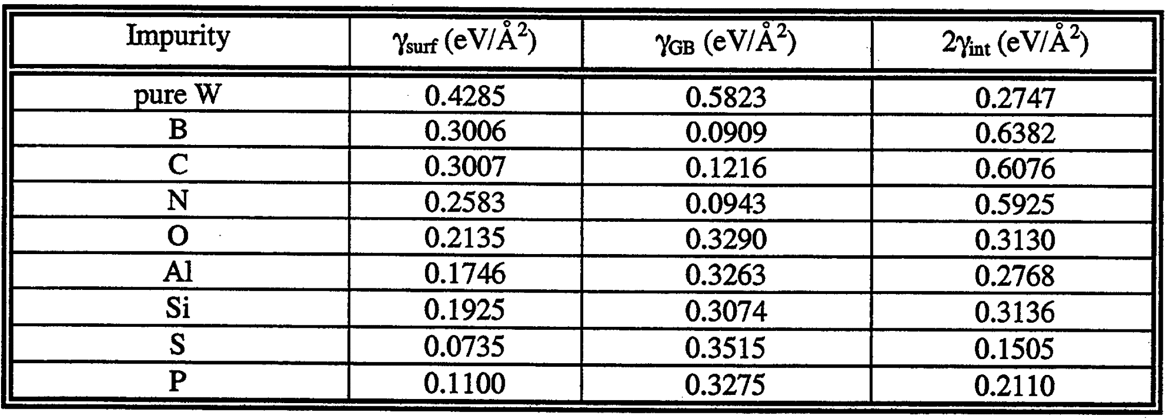

Figure 15 Surface energy, grain boundary energy and ideal work of grain boundary decohesion for tungsten with different impurities. (Grujicic et al., 1999)

### [Mechanics](https://mooseframework.inl.gov/old/wiki/PhysicsModules/TensorMechanics/)

The strong form of the governing equation on the domain $Ω$ and boundary $Γ=Γιi∪Γgi$ can be stated as follows:





where $σ$ is the Cauchy stress tensor, $σ_{0}$ is an additional source of stress (such as pore pressure), $u$ is the displacement vector, $b$ is the body force per unit volume(?), $n$ is the unit normal to the boundary, $g$ is the prescribed displacement on the boundary and $ι$ is the prescribed traction on the boundary. The weak form of the residual equation is expressed as:



where $(⋅)$ and $⟨⋅⟩$ represent volume and boundary integrals, respectively. The solution of the residual equation with Newton's method requires the Jacobian of the residual equation, which can be expressed as (ignoring boundary terms)



assuming $σ_{0}$ is independent of the strain.

The material stress response is described by the constitutive model, where the stress is determined as a function of the strain, i.e. $σ\sim (ϵ-ϵ_{0}),$ where $ϵ$ is the strain and $ϵ_{0}$ is a stress free strain. For example, in linear elasticity (only valid for small strains), the material response is linear, i.e. $σ=C(ϵ-ϵ_{0}).$ The tensor mechanics system can handle linear elasticity and finite strain mechanics, including both elasticity and plasticity.

### Modifying code

First, we modify the dimensions of the mesh to make it suitable for tens of mkm size of the particles

[Mesh]

  type = GeneratedMesh

  dim = 2

  nx = 60

  ny = 60

  #   nz = 0

  xmin = 60.0

  xmax = 330.0

  ymin = 130.0

  ymax = 340.0

  # zmax = 0

  elem_type = QUAD4

[]

Next, we have to modify the initial conditions to match the mesh scale

|  |  |  |  |
| --- | --- | --- | --- |
| [ICs]    [./ic_gr8]      int_width = 2.0      x1 = 280.9158      y1 = 180.2981      radius = 30.895      outvalue = 0.0      variable = gr8      invalue = 1.0      type = SmoothCircleIC    [../]    [./ic_gr7]      int_width = 2.0      x1 = 100.6328      y1 = 290.4843      radius = 30.75      outvalue = 0.0      variable = gr7      invalue = 1.0      type = SmoothCircleIC    [../]    [./ic_gr6]      int_width = 2.0      x1 = 21.7174      y1 = 15.3236      radius = 3.75      outvalue = 0.0      variable = gr6      invalue = 1.0      type = SmoothCircleIC    [../] | [./ic_gr5]      int_width = 2.0      x1 = 200.0109      y1 = 300.5594      radius = 40.32      outvalue = 0.0      variable = gr5      invalue = 1.0      type = SmoothCircleIC    [../]    [./ic_gr4]      int_width = 2.0      x1 = 270.8199      y1 = 280.1836      radius = 30.375      outvalue = 0.0      variable = gr4      invalue = 1.0      type = SmoothCircleIC    [../]    [./ic_gr3]      int_width = 2.0      x1 = 220.0109      y1 = 220.7441      radius = 30.375      outvalue = 0.0      variable = gr3      invalue = 1.0      type = SmoothCircleIC    [../] | [./ic_gr5]      int_width = 2.0      x1 = 200.0109      y1 = 300.5594      radius = 40.32      outvalue = 0.0      variable = gr5      invalue = 1.0      type = SmoothCircleIC    [../]    [./ic_gr4]      int_width = 2.0      x1 = 270.8199      y1 = 280.1836      radius = 30.375      outvalue = 0.0      variable = gr4      invalue = 1.0      type = SmoothCircleIC    [../]    [./ic_gr3]      int_width = 2.0      x1 = 220.0109      y1 = 220.7441      radius = 30.375      outvalue = 0.0      variable = gr3      invalue = 1.0      type = SmoothCircleIC    [../] | [./ic_g2]      int_width = 2.0      x1 = 130.5818      y1 = 170.6532      radius = 30.375      outvalue = 0.0      variable = gr2      invalue = 1.0      type = SmoothCircleIC    [../]    [./ic_gr1]      int_width = 2.0      x1 = 80.592      y1 = 220.4133      radius = 30.25      outvalue = 0.0      variable = gr1      invalue = 1.0      type = SmoothCircleIC    [../]    [./ic_gr0]      int_width = 2.0      x1 = 150.6702      y1 = 240.1294      radius = 30.25      outvalue = 0.0      variable = gr0      invalue = 1.0      type = SmoothCircleIC    [../] |

  [./multip]

    x_positions = '280.9158 100.6328    210.7174    200.0109    270.8199    220.9458    130.5818    8.592   150.6702'

    y_positions = '180.2981 290.4843    150.3236    300.5594    280.1836    220.7441    170.6532    220.4133    240.1294'

    z_positions = '0 0 0 0 0 0 0 0 0'

    radii = '30.875 30.75   30.75   40.325  30.5    30.375  30.375  30.25   30.25'

    int_width = 2.0

    3D_spheres = false

    outvalue = 0.001

    variable = c

    invalue = 0.999

    type = SpecifiedSmoothCircleIC

    block = 0

  [../]

[]

The first choice we have to make is gravity units. Should we keep mksm/s2 or should we change to mkm/ms2. This choice must be consistent with the units of energy $m⋅\frac{l^{2}}{s^{2}}$

Figure 16 Full sintering of a set of spherical particles.

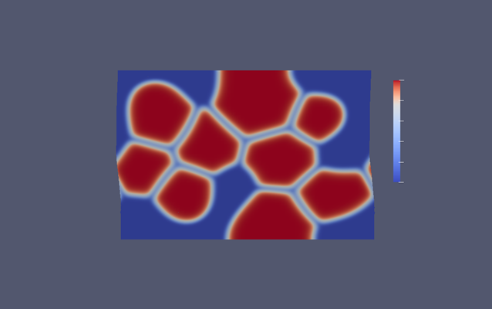

## Example. Spinodal decomposition (<https://mooseframework.inl.gov/old/wiki/MooseTutorials/IronChromiumDecomposition/>)

Consider Cahn-Hillard quation



where *c* is the mole fraction of chromium (unitless), *M*(*c*) is the mobility of chromium ($\frac{m^{2}⋅mol}{J⋅s}$), $f_{loc}(c)$ is the free energy density ($\frac{J}{mol}$),and *κ* is the gradient energy coefficient ($\frac{Jm^{2}}{mol}$). Values for these terms can be looked up in a database or calculated in a thermodynamic software package. while the coefficient *κ* is 8.125×10−16.

In this problem, values were fit to equations which rely on the equation

### Units

The initial condition is given in weight percent, but the equations are given to us on a molar basis. Therefore, we can use the molecular weights of chromium to convert the initial condition from 45 wt% to 46.774 mol% chromium.

In units of meters, the mesh would be entered into MOOSE as 25×10−9 by 25×10−9. However, MOOSE has a built in tolerance that will not allow mesh nodes to be any closer together than 10−6. To get around this we need to change the length scale to units of nanometers. To prevent the values from becoming too large or too small, we will also change the energy scale to units of electron volts. The conversion from meters to nanometers is 109. The conversion from joules to electron volts is 6.24150934×1018. Rather than converting all the values in the table above, we will program these conversions into the input file and do the conversions within the file.

### S1_testmodel.i ([s1_testmodel.i](https://github.com/idaholab/moose/blob/devel/modules/phase_field/tutorials/spinodal_decomposition/s1_testmodel.i))

* Important ideas: use explicit dimensions

  [./constants]

    type = *GenericFunctionMaterial*

    block = 0

    prop_names = 'kappa_c M'

    prop_values = '8.125e-16*6.24150934e+18*1e+09^2*1e-27

                   2.2841e-26*1e+09^2/6.24150934e+18/1e-27'

                   # kappa_c*eV_J*nm_m^2*d

                   # M*nm_m^2/eV_J/d

  [../]

* # Define constant values kappa_c and M.
* # d is a scaling factor that makes it easier for the solution to converge without changing the results. It is defined in each of the materials and must have the same value in each one.

### S2_testmodel.i ([s2_fasttest.i](https://github.com/idaholab/moose/blob/devel/modules/phase_field/tutorials/spinodal_decomposition/s2_fasttest.i))

## A phase field model of pressure-assisted sintering (Dzepina et al., 2019)

There is an issue with the equation for Allen mobility $L$ below eq. (9) in this paper.

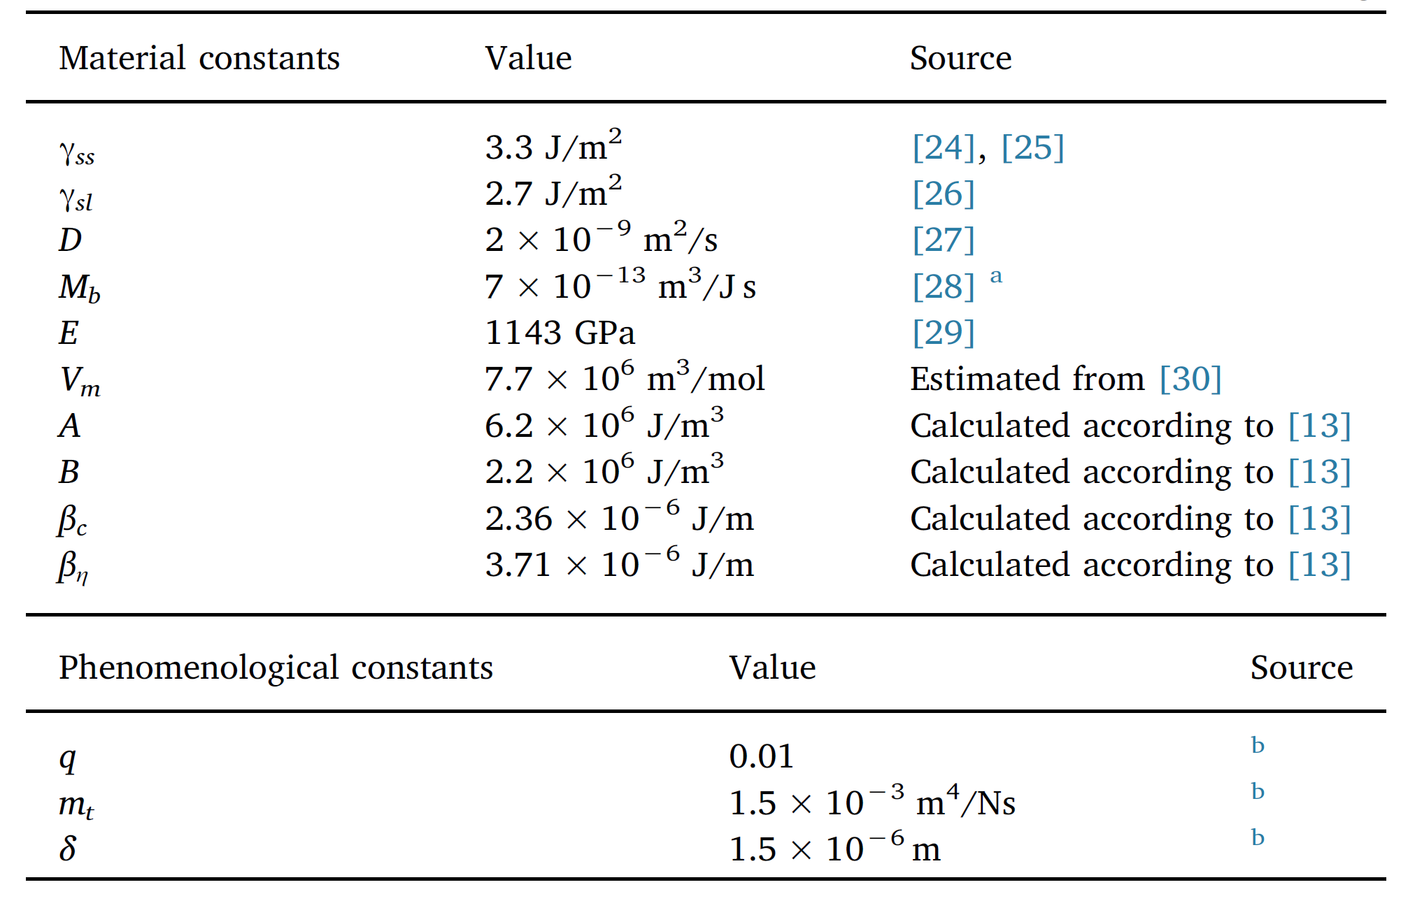



Figure 17 Table of material constants and model parameters for diamond-nickel sintering.

where the variables are defined in Figure 17. The dimension of $L$ must be $l^{3}/(et),$ but it is not.

# Thermomechanical coupling

## Simple examples

### circle_thermal_expansion_stress.i (combined examples)

This example problem demonstrates coupling heat conduction with mechanics. A circular domain has as uniform heat source that increases with time and a fixed temperature on the outer boundary, resulting in a temperature gradient. This results in heterogeneous thermal expansion, where it is pinned in the center. Looking at the hoop stress demonstrates why fuel pellets have radial cracks that extend from the outer boundary to about halfway through the radius. The problem is run with length units of microns.

Figure 18 Mesh and results of simulation of the heat conduction in a circular domain.

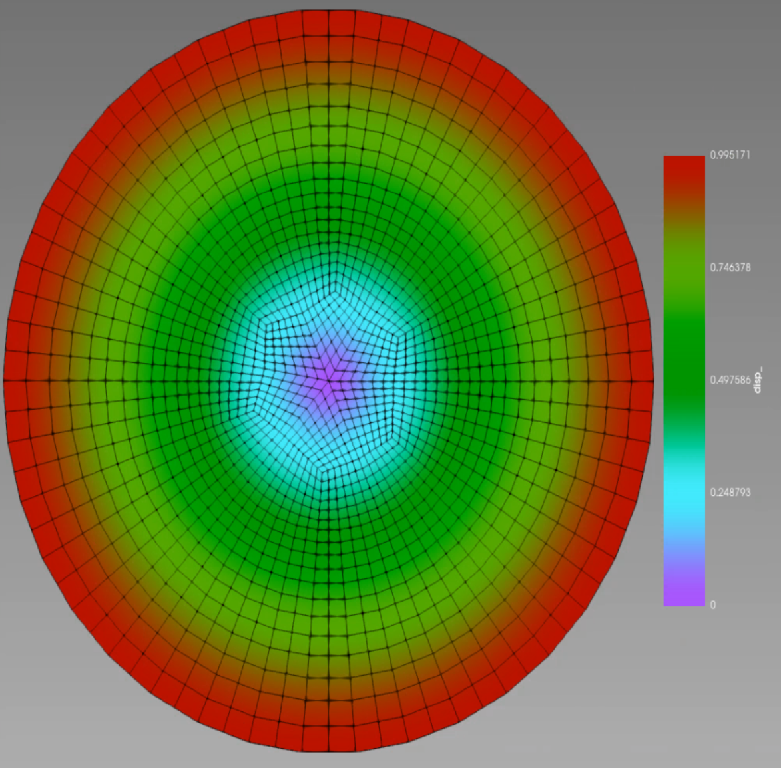

Table 1 Script for thermomechanical coupling in a circular domain.

|  |  |  |
| --- | --- | --- |
| [Mesh]    #Circle mesh has a radius of 1000 units    type = *FileMesh*    file = circle.e    uniform_refine = 1  []  [Variables]    # We solve for the temperature and the displacements    [./T]      initial_condition = 800      scaling = 1e7    [../]    [./disp_x]    [../]    [./disp_y]    [../]  []  [AuxVariables]    [./radial_stress]      order = CONSTANT      family = MONOMIAL    [../]    [./hoop_stress]      order = CONSTANT      family = MONOMIAL    [../]  []  [Kernels]    active = 'TensorMechanics htcond Q_function'    [./htcond] #Heat conduction equation      type = *HeatConduction*      variable = T    [../]    [./TensorMechanics] #Action that creates equations for disp_x and disp_y      displacements = 'disp_x disp_y'    [../]    [./Q_function] #Heat generation term      type = *BodyForce*      variable = T      value = 1      function = 0.8e-9*t    [../]  [] | [AuxKernels]    [./radial_stress] #Calculates radial stress from cartesian      type = *CylindricalRankTwoAux*      variable = radial_stress      rank_two_tensor = stress      index_j = 0      index_i = 0      center_point = '0 0 0'    [../]    [./hoop_stress] #Calculates hoop stress from cartesian      type = *CylindricalRankTwoAux*      variable = hoop_stress      rank_two_tensor = stress      index_j = 1      index_i = 1      center_point = '0 0 0'    [../]  []  [BCs]    [./outer_T] #Temperature on outer edge is fixed at 800K      type = *DirichletBC*      variable = T      boundary = 1      value = 800    [../]    [./outer_x] #Displacements in the x-direction are fixed in the center      type = *DirichletBC*      variable = disp_x      boundary = 2      value = 0    [../]    [./outer_y] #Displacements in the y-direction are fixed in the center      type = *DirichletBC*      variable = disp_y      boundary = 2      value = 0    [../]  []  [Materials]    [./thcond] #Thermal conductivity is set to 5 W/mK      type = *GenericConstantMaterial*      block = 1      prop_names = 'thermal_conductivity'      prop_values = '5e-6'    [../] | [./iso_C] #Sets isotropic elastic constants      type = *ComputeElasticityTensor*      fill_method = symmetric_isotropic      C_ijkl = '2.15e5 0.74e5'      block = 1    [../]    [./strain] #We use small deformation mechanics      type = *ComputeSmallStrain*      displacements = 'disp_x disp_y'      block = 1      eigenstrain_names = eigenstrain    [../]    [./stress] #We use linear elasticity      type = *ComputeLinearElasticStress*      block = 1    [../]    [./thermal_strain]      type= *ComputeThermalExpansionEigenstrain*      thermal_expansion_coeff = 1e-6      temperature = T      stress_free_temperature = 273      block = 1      eigenstrain_name = eigenstrain    [../]  []  [Executioner]    type = *Transient*    scheme = bdf2    num_steps = 10    solve_type = PJFNK    petsc_options_iname = '-pc_type -pc_hypre_type -ksp_gmres_restart'    petsc_options_value = 'hypre boomeramg 101'    l_max_its = 30    nl_max_its = 10    nl_abs_tol = 1e-9    l_tol = 1e-04  []  [Outputs]    exodus = true    perf_graph = true  [] |

The script analysis.

* Read mesh from file circle.e
* Define variables T, disp_x, disp_y.
* Define initial conditions for T on the fly. Note “scaling = 1e7”[1]
* Additional variables are calculated in AuxKernels
* Kernels: htconduction, TensorMechanics,Q_function[2]

## Darcy Flow Tutorial

### Equations of motion (<https://mooseframework.inl.gov/old/wiki/MooseTutorials/DarcyThermoMechanical/Problem/>)



where $\vec{u}$  is the fluid velocity, $ϵ$ is porosity, $K$ is the permeability tensor, $μ$ is fluid viscosity, $p$ is the pressure, $\vec{g}$ is the gravity vector, and $T$ is the temperature. The parameters $ρ$, $C$, and $k$ are the porosity-dependent density, heat capacity, and thermal conductivity of the combined fluid/solid medium, defined by:



where $ϵ$ is the porosity, $c_{p}$ is the specific heat, and the subscripts $f$ and $s$ refer to fluid and solid, respectively.

### Steps

#### Step 01 (<https://mooseframework.inl.gov/old/wiki/MooseTutorials/DarcyThermoMechanical/Step01/>)

Solve 

Figure 19 Solution of Step1.i

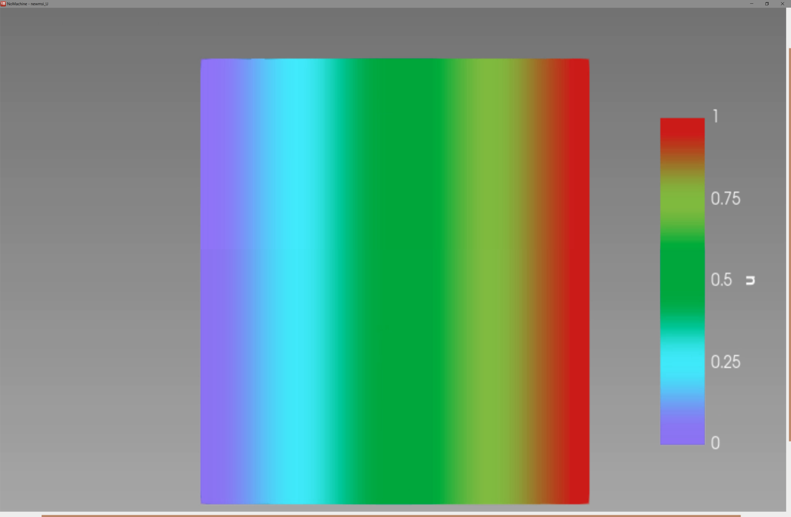

To use step*.py files for plotting add

export PYTHONPATH=/full/path/to/moose/python:$PYTHONPATH

to .bashrc file

#### Step 2 (<https://mooseframework.inl.gov/old/wiki/MooseTutorials/DarcyThermoMechanical/Step02/> )



Figure 20 Solution of Step2.i

#### Step 3 (<https://mooseframework.inl.gov/old/wiki/MooseTutorials/DarcyThermoMechanical/Step03/> )

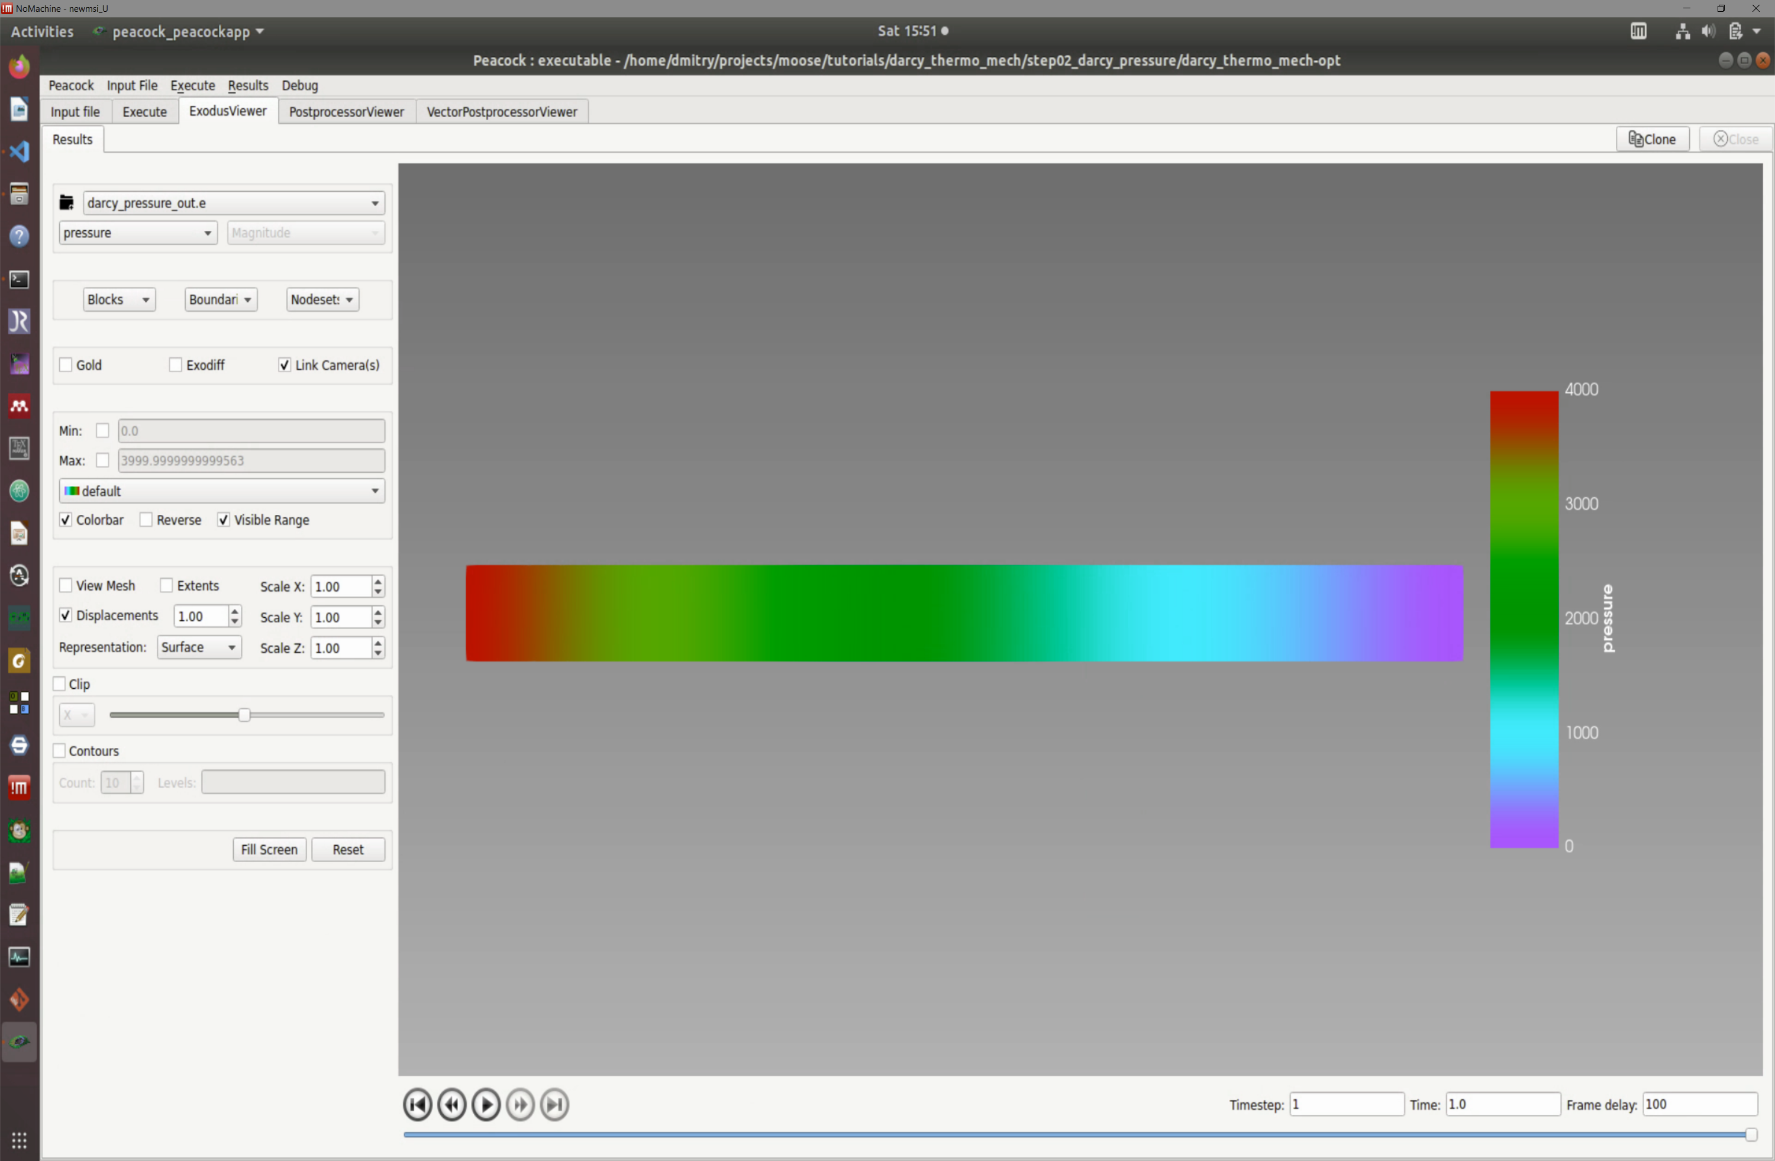

Note that so far only minor changes were introduced to the script in Table 1.

* The kernel was changed from

  [diffusion]

    type = *ADDiffusion*  # Laplacian operator using automatic differentiation

    variable = pressure # Operate on the "pressure" variable from above

  []

to

  [darcy_pressure]

    type = *DarcyPressure*

    variable = pressure

  []

* Material section was added

[Materials]

  [column]

    type = *PackedColumn*

  []

[

* Solver_type was changed from NEWTON to PJFNK [3]

#### Step 4

Added AuxVariables and Kernels for velocity

Table 2 Additions at step 4

|  |  |
| --- | --- |
| [AuxVariables]    [velocity_x]      order = CONSTANT      family = MONOMIAL    []    [velocity_y]      order = CONSTANT      family = MONOMIAL    []    [velocity_z]      order = CONSTANT      family = MONOMIAL    []    [velocity]      order = CONSTANT      family = MONOMIAL_VEC    []  []  [AuxKernels]    [velocity]      type = *DarcyVelocity*      variable = velocity      execute_on = timestep_end      pressure = pressure    [] | [velocity_x]      type = *VectorVariableComponentAux*      variable = velocity_x      component = x      execute_on = timestep_end      vector_variable = velocity    []    [velocity_y]      type = *VectorVariableComponentAux*      variable = velocity_y      component = y      execute_on = timestep_end      vector_variable = velocity    []    [velocity_z]      type = *VectorVariableComponentAux*      variable = velocity_z      component = z      execute_on = timestep_end      vector_variable = velocity    []  [] |

#### Step 5. Heat conduction



Table 3 Heat conduction: step5c_outflow.i (check the steady version Step5a_steady.i)

|  |  |
| --- | --- |
| [Mesh]    type = *GeneratedMesh*    dim = 2    nx = 100    ny = 10    xmax = 0.304 # Length of test chamber    ymax = 0.0257 # Test chamber radius  []  [Variables]    [temperature]      initial_condition = 300 # Start at room temperature    []  []  [Kernels]    [heat_conduction]      type = *ADHeatConduction*      variable = temperature    []    [heat_conduction_time_derivative]      type = *ADHeatConductionTimeDerivative*      variable = temperature    []  []  [BCs]    [inlet_temperature]      type = *DirichletBC*      variable = temperature      boundary = left      value = 350 # (K)    [] | [outlet_temperature]      type = *HeatConductionOutflow*      variable = temperature      boundary = right    []  []  [Materials]    [steel]      type = *GenericConstantMaterial*      prop_names = 'thermal_conductivity specific_heat density'      prop_values = '18 466 8000' # W/m*K, J/kg-K, kg/m^3 @ 296K    []  []  [Problem]    type = *FEProblem*    coord_type = RZ    rz_coord_axis = X  []  [Executioner]    type = *Transient*    num_steps = 100    solve_type = NEWTON    petsc_options_iname = '-pc_type -pc_hypre_type'    petsc_options_value = 'hypre boomeramg'  []  [Outputs]    exodus = true  [] |

#### Step 6 Darcy and heat conduction coupling



Table 4 Step6_coupled.i

|  |  |  |
| --- | --- | --- |
| [Mesh]    type = *GeneratedMesh*    dim = 2    nx = 200    ny = 10    xmax = 0.304 # Length of test chamber    ymax = 0.0257 # Test chamber radius  []  [Variables]    [pressure]    []    [temperature]      initial_condition = 300 # Start at room temperature    []  []  [AuxVariables]    [velocity]      order = CONSTANT      family = MONOMIAL_VEC    []  []  [Kernels]    [darcy_pressure]      type = *DarcyPressure*      variable = pressure    []    [heat_conduction]      type = *ADHeatConduction*      variable = temperature    []    [heat_conduction_time_derivative]      type = *ADHeatConductionTimeDerivative*      variable = temperature    []    [heat_convection]      type = *DarcyAdvection*      variable = temperature      pressure = pressure    []  [] | [AuxKernels]    [velocity]      type = *DarcyVelocity*      variable = velocity      execute_on = timestep_end      pressure = pressure    []  []    [BCs]    [inlet]      type = *DirichletBC*      variable = pressure      boundary = left      value = 4000 # (Pa) From Figure 2 from paper.  First data point for 1mm spheres.    []    [outlet]      type = *DirichletBC*      variable = pressure      boundary = right      value = 0 # (Pa) Gives the correct pressure drop from Figure 2 for 1mm spheres    []    [inlet_temperature]      type = *FunctionDirichletBC*      variable = temperature      boundary = left      function = 'if(t<0,350+50*t,350)'    []    [outlet_temperature]      type = *HeatConductionOutflow*      variable = temperature      boundary = right    []  [] | [Materials]    [column]      type = *PackedColumn*      temperature = temperature      radius = 1    []  []  [Problem]    type = *FEProblem*    coord_type = RZ    rz_coord_axis = X  []  [Executioner]    type = *Transient*    solve_type = NEWTON    automatic_scaling = true    petsc_options_iname = '-pc_type -pc_hypre_type'    petsc_options_value = 'hypre boomeramg'    end_time = 100    dt = 0.25    start_time = -1    steady_state_tolerance = 1e-5    steady_state_detection = true    [TimeStepper]      type = *FunctionDT*      function = 'if(t<0,0.1,0.25)'    []  []  [Outputs]    exodus = true  [] |

It can be seen form the Table 4 that the coupled set of equations is a straightforward combination of the individual solvers considered earlier. Similarly, one can add Mechanics module to the calculations.

One has to remember though that “Mechanics” Mechanics is a complicated beast, see <https://www.mooseframework.org/modules/tensor_mechanics/index.html> . The steps required to include “Mechanics” module are discussed here

<https://mooseframework.inl.gov/old/wiki/MooseTutorials/DarcyThermoMechanical/Step09/> .

#### Step9



Table 5 Step9.i

|  |  |  |  |
| --- | --- | --- | --- |
| [GlobalParams]    displacements = 'disp_r disp_z'  []  [Mesh]    type = *GeneratedMesh*    dim = 2    ny = 200    nx = 10    ymax = 0.304 # Length of test chamber    xmax = 0.0257 # Test chamber radius  []  [MeshModifiers]    [bottom]      type = *SubdomainBoundingBox*      location = inside      bottom_left = '0 0 0'      top_right = '0.01285 0.304 0'      block_id = 1    []  []  [Variables]    [pressure]    []    [temperature]      initial_condition = 300 # Start at room temperature    []  []  [AuxVariables]    [velocity]      order = CONSTANT      family = MONOMIAL_VEC    []  []  [Modules/TensorMechanics/Master]    [all]      # This block adds all of the proper Kernels, strain calculators, and Variables      # for TensorMechanics in the correct coordinate system (autodetected)      add_variables = true      strain = FINITE      eigenstrain_names = eigenstrain      use_automatic_differentiation = true      generate_output = 'vonmises_stress elastic_strain_xx elastic_strain_yy strain_xx strain_yy'    []  [] | [Kernels]    [darcy_pressure]      type = *DarcyPressure*      variable = pressure    []    [heat_conduction]      type = *ADHeatConduction*      variable = temperature    []    [heat_conduction_time_derivative]      type = *ADHeatConductionTimeDerivative*      variable = temperature    []    [heat_convection]      type = *DarcyAdvection*      variable = temperature      pressure = pressure    []  []  [AuxKernels]    [velocity]      type = *DarcyVelocity*      variable = velocity      execute_on = timestep_end      pressure = pressure    []  []  [BCs]    [inlet]      type = *DirichletBC*      variable = pressure      boundary = bottom      value = 4000 # (Pa) From Figure 2 from paper.  First data point for 1mm spheres.    []    [outlet]      type = *DirichletBC*      variable = pressure      boundary = top      value = 0 # (Pa) Gives the correct pressure drop from Figure 2 for 1mm spheres    []    [inlet_temperature]      type = *FunctionDirichletBC*      variable = temperature      boundary = bottom      function = 'if(t<0,350+50*t,350)'    []    [outlet_temperature]      type = *HeatConductionOutflow*      variable = temperature      boundary = top    []    [] | [hold_inlet]      type = *DirichletBC*      variable = disp_z      boundary = bottom      value = 0    []    [hold_center]      type = *DirichletBC*      variable = disp_r      boundary = left      value = 0    []    [hold_outside]      type = *DirichletBC*      variable = disp_r      boundary = right      value = 0    []  []  [Materials]    viscosity_file = data/water_viscosity.csv    density_file = data/water_density.csv    thermal_conductivity_file = data/water_thermal_conductivity.csv    specific_heat_file = data/water_specific_heat.csv    thermal_expansion_file = data/water_thermal_expansion.csv    [column_top]      type = *PackedColumn*      block = 0      temperature = temperature      radius = 1.15      fluid_viscosity_file = ${viscosity_file}      fluid_density_file = ${density_file}      fluid_thermal_conductivity_file = ${thermal_conductivity_file}      fluid_specific_heat_file = ${specific_heat_file}      fluid_thermal_expansion_file = ${thermal_expansion_file}    []    [column_bottom]      type = *PackedColumn*      block = 1      temperature = temperature      radius = 1      fluid_viscosity_file = ${viscosity_file}      fluid_density_file = ${density_file}      fluid_thermal_conductivity_file = ${thermal_conductivity_file}      fluid_specific_heat_file = ${specific_heat_file}      fluid_thermal_expansion_file = ${thermal_expansion_file}    [] | [elasticity_tensor]      type = *ComputeIsotropicElasticityTensor*      youngs_modulus = 200e9 # (Pa) from wikipedia      poissons_ratio = .3 # from wikipedia    []    [elastic_stress]      type = *ADComputeFiniteStrainElasticStress*    []    [thermal_strain]      type = *ADComputeThermalExpansionEigenstrain*      stress_free_temperature = 300      eigenstrain_name = eigenstrain      temperature = temperature      thermal_expansion_coeff = 1e-5 # TM modules doesn't support material property, but it will    []  []  [Postprocessors]    [average_temperature]      type = *ElementAverageValue*      variable = temperature    []  []  [Problem]    type = *FEProblem*    coord_type = RZ  []  [Executioner]    type = *Transient*    start_time = -1    end_time = 200    steady_state_tolerance = 1e-7    steady_state_detection = true    dt = 0.25    solve_type = PJFNK    automatic_scaling = true    compute_scaling_once = false    petsc_options_iname = '-pc_type'    petsc_options_value = 'lu'    #petsc_options_iname = '-pc_type -pc_hypre_type -ksp_gmres_restart'    #petsc_options_value = 'hypre boomeramg 500'    line_search = none    [TimeStepper]      type = *FunctionDT*      function = 'if(t<0,0.1,0.25)'    []  []  [Outputs]    [out]      type = *Exodus*      elemental_as_nodal = true    [] |

Figure 21 Results of simulatins at Step9.i

# Using SINK boundary conditions

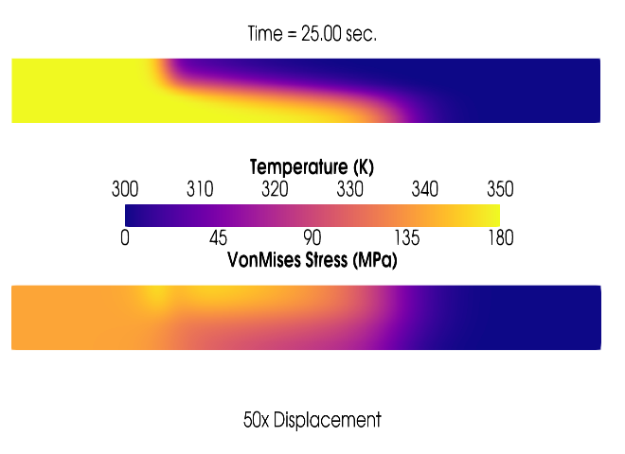

Question: Is the parsed function of MOOSE capable of moving a heat source (e.g. laser scanning) ? (<https://groups.google.com/forum/#!topic/moose-users/J5M6-MNPdiI> )

Answer: Sure - if it's an actual boundary condition (like, it's applied on the boundary) then it's pretty straightforward to do with a ***parsed function*** and ***FunctionBC***.

## Basic sink formulation

The basic sink is

$$s=f(t,x)$$

where $f$ is a MOOSE Function of time and position on the boundary.

If $f>0$ then the boundary condition will act as a sink, while if $f<0$ the boundary condition acts as a source. If applied to a fluid-component equation, the function $f$ has units kg.m−2.s−1. If applied to the heat equation, the function $f$ has units J.m−2.s−1. The units of $f$ are potentially modified if the extra building blocks enumerated below are used (but the units of the final result, $s$, will always be kg.m−2.s−1 or J.m−2.s−1).

If the fluid flow through the boundary is required, use the ***save_in*** command which will save the sink strength to an ***AuxVariable***. This AuxVariable will be the flux (kg.s−1 or J.s−1) from each node on the boundary, which is the product of $s$ and the area attributed to that node. If the total flux (kg.s−1 or J.s−1) through the boundary is required, integrate the AuxVariable over the boundary using a ***NodalSum*** Postprocessor.

This basic sink boundary condition is implemented in ***PorousFlowSink*** (<https://www.mooseframework.org/source/bcs/PorousFlowSink.html> ).

## Sink tests ([https://www.mooseframework.org/modules/porous_flow/tests/sinks/sinks_tests.html#](https://www.mooseframework.org/modules/porous_flow/tests/sinks/sinks_tests.html)! )

### Test 1

Table 6. Script for Test1 of sink

|  |  |  |
| --- | --- | --- |
| # apply a sink flux and observe the correct behavior  [Mesh]    type = *GeneratedMesh*    dim = 3    nx = 1    ny = 1    nz = 1    xmin = 0    xmax = 1    ymin = 0    ymax = 1    zmin = 0    zmax = 2  []  [GlobalParams]    PorousFlowDictator = dictator  []  [UserObjects]    [./dictator]      type = *PorousFlowDictator*      porous_flow_vars = 'pp'      number_fluid_phases = 1      number_fluid_components = 1    [../]    [./pc]      type = *PorousFlowCapillaryPressureVG*      m = 0.5      alpha = 1    [../]  []  [Variables]    [./pp]    [../]  []  [ICs]    [./pp]      type = *FunctionIC*      variable = pp      function = y+1    [../]  []  [Kernels]    [./mass0]      type = *PorousFlowMassTimeDerivative*      fluid_component = 0      variable = pp    [../]  []  [Modules]    [./FluidProperties]      [./simple_fluid]        type = *SimpleFluidProperties*        bulk_modulus = 1.3        density0 = 1.1        thermal_expansion = 0        viscosity = 1.1      [../]    [../]  []  [Materials]    [./temperature]      type = *PorousFlowTemperature*    [../]    [./ppss]      type = *PorousFlow1PhaseP*      porepressure = pp      capillary_pressure = pc    [../]    [./massfrac]      type = *PorousFlowMassFraction*    [../] | [./simple_fluid]      type = *PorousFlowSingleComponentFluid*      fp = simple_fluid      phase = 0    [../]    [./porosity]      type = *PorousFlowPorosityConst*      porosity = 0.1    [../]    [./permeability]      type = *PorousFlowPermeabilityConst*      permeability = '1E-5 0 0 0 1E-5 0 0 0 1E-5'    [../]    [./relperm]      type = *PorousFlowRelativePermeabilityCorey*      n = 2      phase = 0    [../]  []  [AuxVariables]    [./flux_out]    [../]    [./xval]    [../]    [./yval]    [../]  []  [ICs]    [./xval]      type = *FunctionIC*      variable = xval      function = x    [../]    [./yval]      type = *FunctionIC*      variable = yval      function = y    [../]  []  [Functions]    [./mass00]      type = *ParsedFunction*      value = 'vol*por*dens0*exp(pp/bulk)'      vars = 'vol por dens0 pp bulk'      vals = '0.25 0.1 1.1 p00 1.3'    [../]    [./mass01]      type = *ParsedFunction*      value = 'vol*por*dens0*exp(pp/bulk)'      vars = 'vol por dens0 pp bulk'      vals = '0.25 0.1 1.1 p01 1.3'    [../]    [./expected_mass_change00]      type = *ParsedFunction*      value = 'fcn*perm*dens0*exp(pp/bulk)/visc*area*dt'      vars = 'fcn perm dens0 pp bulk visc area dt'      vals = '6   1    1      0  1.3  1  0.5  1E-3'    [../]  []  [Postprocessors]    [./p00]      type = *PointValue*      point = '0 0 0'      variable = pp      execute_on = 'initial timestep_end'    [../]    [./m00]      type = *FunctionValuePostprocessor*      function = mass00      execute_on = 'initial timestep_end'    [../] | [./del_m00]      type = *FunctionValuePostprocessor*      function = expected_mass_change00      execute_on = 'timestep_end'    [../]     [./p10]      type = *PointValue*      point = '1 0 0'      variable = pp      execute_on = 'initial timestep_end'    [../]   [./p01]      type = *PointValue*      point = '0 1 0'      variable = pp      execute_on = 'initial timestep_end'    [../]    [./m01]      type = *FunctionValuePostprocessor*      function = mass01      execute_on = 'initial timestep_end'    [../]    [./p11]      type = *PointValue*      point = '1 1 0'      variable = pp      execute_on = 'initial timestep_end'    [../]  []  [BCs]    [./flux]      type = *PorousFlowSink*      boundary = 'left'      variable = pp      use_mobility = false      use_relperm = true      fluid_phase = 0      flux_function = 6      save_in = flux_out    [../]  []  [Preconditioning]    [./andy]      type = *SMP*      full = true      petsc_options_iname = '-ksp_type -pc_type -sub_pc_type -snes_max_it -sub_pc_factor_shift_type -pc_asm_overlap'      petsc_options_value = 'gmres asm lu 10000 NONZERO 2'    [../]  []  [Executioner]    type = *Transient*    solve_type = Newton    dt = 1E-3    end_time = 1E-2    nl_rel_tol = 1E-12    nl_abs_tol = 1E-12  []  [Outputs]    file_base = s01    [./console]      type = *Console*      execute_on = 'nonlinear linear'    [../]    [./csv]      type = *CSV*      execute_on = 'initial timestep_end'    [../]  [] |

### Gaussian moving heat source

Table 7 Moving Gaussian source for pure heat conduction in generic material

|  |  |  |
| --- | --- | --- |
| # This test solves a 1D transient heat equation  # The error is caclulated by comparing to the analytical solution  # The problem setup and analytical solution are taken from "Advanced Engineering  # Mathematics, 10th edition" by Erwin Kreyszig.  # http://www.amazon.com/Advanced-Engineering-Mathematics-Erwin-Kreyszig/dp/0470458364  # It is Example 1 in section 12.6 on page 561  [Mesh]    type = *GeneratedMesh*    dim = 3    nx = 30    ny = 30    nz = 30    xmax = 30    ymax = 30    zmax = 10  []  [Variables]    [./T]    [../]  []  [Kernels]    [./HeatSource]      type = *HeatSource*      # function = '1*sin(3.14159*x/20)*sin(3.14159*y/80)*sin(3.14159*z/20)'      function = '10*exp(-((x-(30-2*t))^2+(y-(30-2*t))^2)/20)*exp(-z/1.5)'      variable = T    [../]    [./HeatDiff]      type = *HeatConduction*      variable = T    [../]    [./HeatTdot]      type = *HeatConductionTimeDerivative*      variable = T    [../]  [] | [BCs]    [./left]      type = *DirichletBC*      variable = T      boundary = left      value = 0    [../]    [./right]      type = *DirichletBC*      variable = T      boundary = right      value = 0    [../]    [./top]      type = *DirichletBC*      variable = T      boundary = top      value = 0    [../]    [./bottom]      type = *DirichletBC*      variable = T      boundary = bottom      value = 0    [../]  []  [Materials]    [./k]      type = *GenericConstantMaterial*      prop_names = 'thermal_conductivity'      prop_values = '0.95' #copper in cal/(cm sec C)      block = 0    [../]    [./cp]      type = *GenericConstantMaterial*      prop_names = 'specific_heat'      prop_values = '0.092' #copper in cal/(g C)      block = 0    [../] | [./rho]      type = *GenericConstantMaterial*      prop_names = 'density'      prop_values = '8.92' #copper in g/(cm^3)      block = 0    [../]  []  [Postprocessors]    [./error]      type = *NodalL2Error*      function = '100*sin(3.14159*x/20)*exp(-0.95/(0.092*8.92)*3.14159^2/20^2*t)' #T(x,t) = 100sin(pix/L)exp(-rho/(cp k) pi^2/L^2 t)      variable = T    [../]  []  [Executioner]    type = *Transient*    scheme = bdf2    nl_rel_tol = 1e-12    l_tol = 1e-8    dt = 0.025    #end_time = 100    end_time = 10    petsc_options_iname = '-pc_type -pc_hypre_type'    petsc_options_value = 'hypre boomeramg'  []  [Outputs]    exodus = true    print_perf_log = true  [] |

# Adding heat source to the phase-field model of sintering

We review the following publications [7] and [10].

In the paper by X. Zhang and Y. Liao [10] the authors develop MOOSE model of Selective Laser Sintering by adding thermal module to the Biswas [1], [2] model of sintering



$ρ\frac{∂C_{p} T}{∂t}= ∇\left(k_{e} ∇T\right) k_{e}=k{\left(1-θ\right)}^{p} T\left(x,y,z,0\right)=T_{0}$

# References

1. Biswas, S., Schwen, D., Singh, J., & Tomar, V. (2016). A study of the evolution of microstructure and consolidation kinetics during sintering using a phase field modeling based approach. *Extreme Mechanics Letters*, *7*, 78–89. https://doi.org/10.1016/j.eml.2016.02.017
2. Biswas, S., Schwen, D., & Tomar, V. (2018). Implementation of a phase field model for simulating evolution of two powder particles representing microstructural changes during sintering. *Journal of Materials Science*, *53*(8), 5799–5825. https://doi.org/10.1007/s10853-017-1846-3
3. C. Minkwitz, and C. H. J. S. L. (1997). Grain Boundary Self-Diffusion in Polycrystalline Tungsten at Low Temperatures. *Physica Status Solidi (B)*, *202*(2), 931–940. https://doi.org/10.1002/1521-3951(199708)202:2<931::AID-PSSB931>3.0.CO;2-O
4. Chockalingam, K., Kouznetsova, V. G., van der Sluis, O., & Geers, M. G. D. (2016). 2D Phase field modeling of sintering of silver nanoparticles. *Computer Methods in Applied Mechanics and Engineering*, *312*(2016), 492–508. https://doi.org/10.1016/j.cma.2016.07.002
5. Dzepina, B., Balint, D., & Dini, D. (2019). Journal of the European Ceramic Society A phase fi eld model of pressure-assisted sintering. *Journal of the European Ceramic Society*, *39*(2–3), 173–182. https://doi.org/10.1016/j.jeurceramsoc.2018.09.014
6. Grujicic, M., Zhao, H., & Krasko, G. L. (1999). *Atomistic Simulation of Sigma 3 (111) Grain Boundary Fracture in Tungsten Containing Various Impurities*.
7. Yang, Q., Kirshtein, A., Ji, Y., Liu, C., Shen, J., & Chen, L. Q. (2018). A thermodynamically consistent phase‐field model for viscous sintering. *Journal of the American Ceramic Society*, *102*(2), 674–685. https://doi.org/10.1111/jace.16021
8. Yang, Y., Kühn, P., Yi, M., Egger, H., & Xu, B. X. (2020). Non-isothermal Phase-Field Modeling of Heat–Melt–Microstructure-Coupled Processes During Powder Bed Fusion. *Jom*. https://doi.org/10.1007/s11837-019-03982-y
9. Yang, Y., Ragnvaldsen, O., Bai, Y., Yi, M., & Xu, B. X. (2019). 3D non-isothermal phase-field simulation of microstructure evolution during selective laser sintering. *Npj Computational Materials*, *5*(1). https://doi.org/10.1038/s41524-019-0219-7
10. Zhang, X., & Liao, Y. (2018). A phase-field model for solid-state selective laser sintering of metallic materials. *Powder Technology*, *339*, 677–685. https://doi.org/10.1016/j.powtec.2018.08.025

1. you may have very poor scaling between variables in a multi-physics simulation. You may even have run into issues if you have nodal boundary conditions (which introduce values of unity on the diagonals) and the Jacobian entries from your physics (kernels) are very large. You want your condition number to be as close to unity as possible. To address the latter problem or poor relative scaling between variables, you can use MOOSE's automatic scaling feature which will bring different physics Jacobians as close to unity as possible. To turn on this feature, set the automatic_scaling parameter in the Executioner block to true. Additionally, if you want to update scaling factors at every time step then set Executioner/compute_scaling_once=false. By default this latter parameter is set to true in order to save computational expense.
2. Heat source term
3. **NEWTON** - Direct solution of the system of equations using Newton's method. The full and accurate Jacobian is required. Thus, the [Preconditioner](http://mooseframework.org/wiki/MooseSystems/Preconditioners/) block must be employed for systems with multiple nonlinear variables.

   **JFNK** - The system is solved using Jacobian Free Newton Krylov (JFNK), so no Jacobian terms are needed. However, JFNK often does not perform well without preconditioning.

   **PJFNK** - The system is solved using preconditioned JFNK. The Jacobian is used to precondition the matrix, but it does not have to be fully correct and can neglect off-diagonal terms.